Improving Usability of Conversational AI through Context-Aware Re-finding Interaction
Team 2 (HyeokJae Cho, Hyunji Jeong, Boyoung Kwon, Suyoung Kwon, Jieun Woo)

1. Introduction

1.1. Overview of Conversational AI Service Trends
Recent conversational AI services have diversified into several categories. First, general-purpose conversational AI services, such as ChatGPT, Claude, and Gemini, are widely used for information seeking, writing, brainstorming, learning, and everyday task support. These systems are designed for broad conversational interaction and are increasingly adopted as multipurpose assistants across domains. Second, coding-oriented AI assistants have emerged to support software development workflows more directly. Examples include GitHub Copilot, OpenAI Codex, Gemini Code Assist, and Claude Code, which provide functionalities such as code generation, explanation, debugging, and agentic assistance within development environments. This diversification suggests that conversational AI services are no longer limited to standalone question-answering tools, but are evolving into task-oriented platforms that support ongoing, context-rich user workflows. As users engage with these services across a wider range of tasks, the volume and value of past conversations increase accordingly, making the retrieval and reuse of prior interactions an increasingly important usability issue. Despite this growing need, existing conversational AI services still provide limited support for effectively retrieving, revisiting, and reusing past interactions.

1.2. Current Limitations
Our analysis of current conversational AI services identified three design limitations that may hinder users’ ability to re-find past conversations efficiently.
A. Limited Search Scope and Logic
Many conversational AI services provide only limited support for locating past conversations through search. In some cases, the searchable scope is restricted to a specific data domain rather than the full interaction history. For example, Cursor offers powerful in-file code search, but excludes conversation logs that may contain important design decisions or explanations behind the code. Similarly, Moonlight supports keyword search within literature, but not within conversation logs. Such domain separation may make it difficult to locate prior interactions when relevant context is distributed across multiple information spaces.
In other cases, search relies heavily on incomplete metadata rather than the full conversational content. Copilot, Claude, and Claude Code, for instance, appear to search primarily through summarized titles or the first question of a session instead of the entire conversation body. This design may reduce the usefulness of search when users remember only partial cues, such as a specific phrase, idea fragment, or explanation that appeared later in the interaction.
In addition, some services employ shallow search logic that may further weaken retrieval quality. Copilot’s search function, for example, uses character-level matching, which can expose many low-value or weakly relevant results. As a result, the search process may become less precise and less effective for re-finding specific past conversations.
B. Linear Navigation and Weak Reorientation Support
A second limitation lies in how conversation histories are structured and navigated after retrieval. Many services present past conversations as chronologically ordered lists, which provide only limited support for quickly returning to a specific point within a prior interaction. Rather than helping users jump directly to the relevant passage, this structure often requires sequential browsing through long session histories.
In ChatGPT, Gemini, and Cursor, the absence of in-conversation search often leaves users reliant on browser-level Cmd+F as a workaround. This can create a repetitive pattern of scrolling and skimming through message bubbles one by one in order to locate a remembered segment of the conversation.
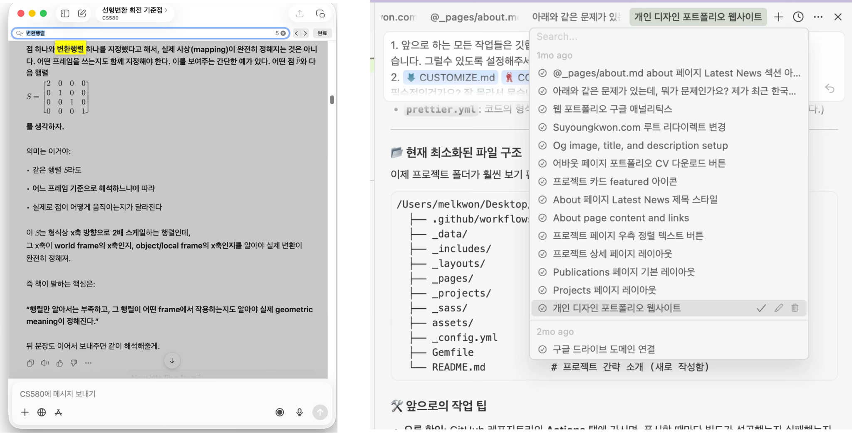
Figure 1. In GPT (left) and Cursor (right), users rely on browser-level Cmd+F as a workaround for the lack of in-conversation search.
Even when search is available, reorientation support may remain weak. In Claude, for example, selecting a thread from the search results does not automatically move the interface to the matched response location, but instead opens the session at its end. This may make it harder to reconnect the retrieved thread with the specific point of relevance.
Temporal cues can also be too coarse to support efficient re-finding. Claude’s broad labels, such as “1 year ago,” provide only limited information for distinguishing among multiple past sessions. When users rely on approximate timing as a memory cue, such coarse labels may offer insufficient support for identifying the intended conversation.Ambiguous temporal cues: In Claude, broad time range labels (e.g., 1 year ago) fail to provide sufficient cues for users to match their internal sense of timing with the conversation log.
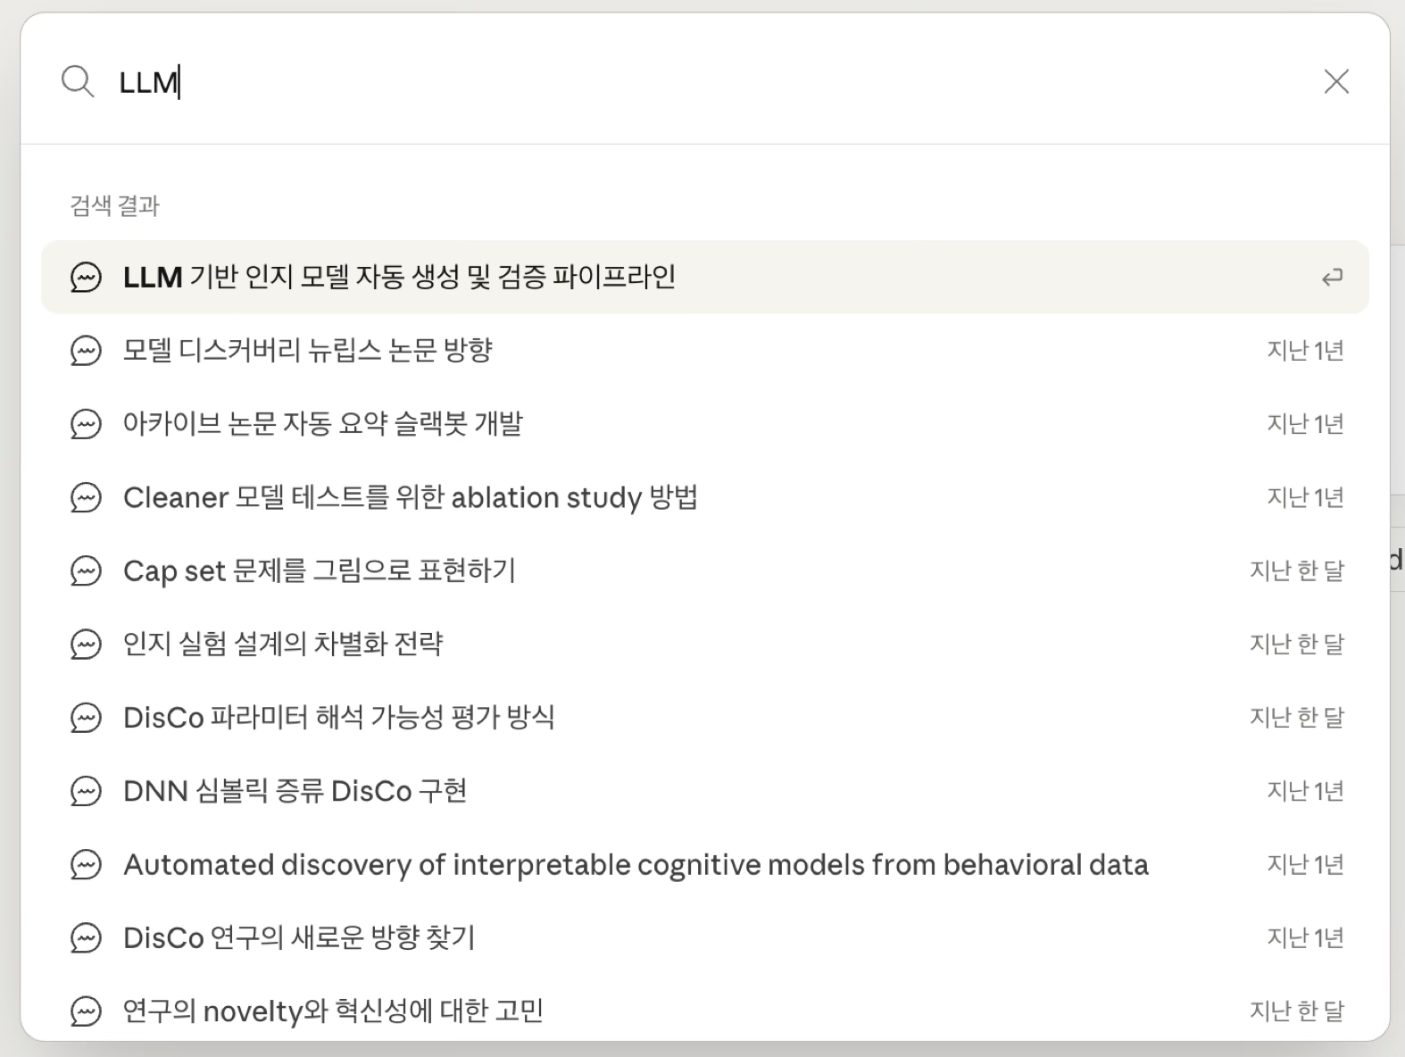
Figure 2. Ambiguous temporal cues in Claude search results.
C. Fragmented Context Management Across Features
A third limitation concerns how context is preserved across different interface features. In several services, information can be extracted, saved, or revisited through separate mechanisms, but the connection to the original interaction context is weakened in the process.
For example, NotebookLM allows generated answers to be saved as notes, but these notes do not always preserve the full relationship to the original question or the surrounding conversational flow. As a result, information may remain accessible while becoming harder to interpret or reuse in its original context.
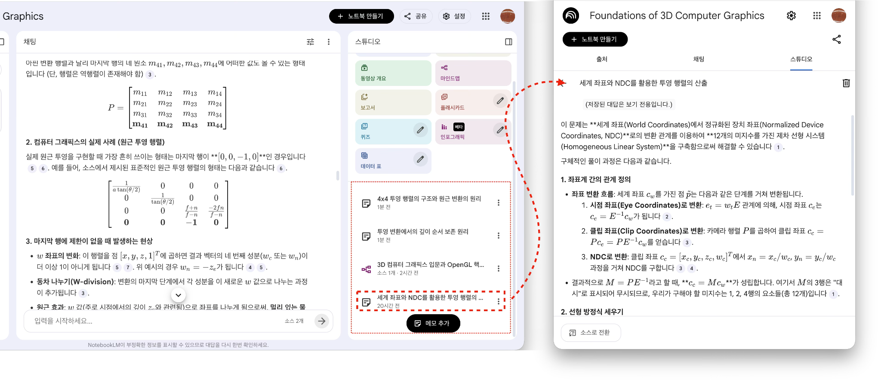
Figure 3. Loss of context in NotebookLM’s saved notes.
A related issue appears when system behavior interferes with familiar navigation practices. In Moonlight, for instance, interaction conflicts with the browser’s native Cmd+F shortcut can disrupt a widely used search behavior. Such interference may reduce consistency between users’ existing habits and the system’s navigation mechanisms.
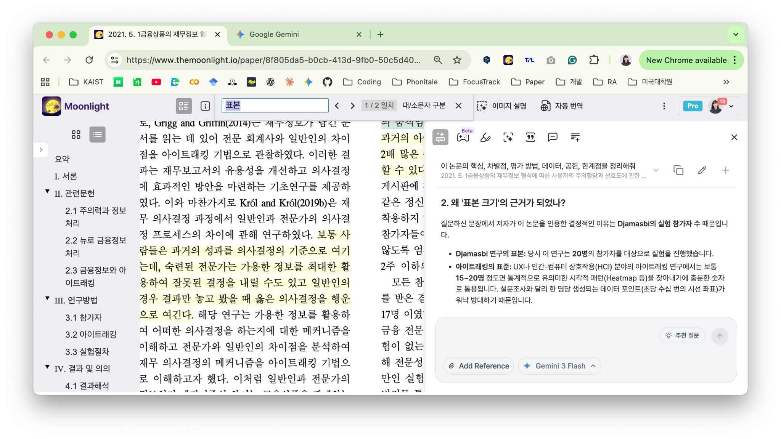
Figure 4. Moonlight’s interference with the browser’s native Cmd+F shortcut.
Taken together, these limitations suggest that current conversational AI services still provide incomplete support for re-finding past anchor conversations, particularly when retrieval depends on partial memory cues, contextual reconstruction, and efficient navigation within long interaction histories.

1.3. Purpose of the Project
As conversational AI services become increasingly embedded in knowledge-intensive workflows, users accumulate rich interaction histories that serve as ongoing reference points across tasks. Yet as described in Section 1.2, current services provide only limited support for retrieving and reusing these past interactions. This project aims to address these gaps by investigating how users actually experience re-finding in practice and by identifying the design requirements that emerge from those experiences. Specifically, we seek to characterize users’ behavioral patterns and pain points around re-finding, analyze the contextual factors that shape when and how it occurs, and derive core system functions that could meaningfully improve the usability of conversational AI for users who depend on prior interactions as a foundation for continued work.

2. Methods

2.1. Participation Selection
Participants were selected based on their relevance to the target users and stakeholders of the proposed system. Because the project focuses on improving re-finding interactions in conversational AI for knowledge-intensive work, the primary participant group was defined as heavy users who regularly integrate conversational AI into academic or research workflows. These users were expected to have substantial experience not only generating responses, but also revisiting, locating, and reusing prior AI interactions across tasks such as literature review, writing, brainstorming, coding, and information seeking.
Accordingly, eight end users were recruited from KAIST graduate students and researchers who use conversational AI for at least approximately two hours per day on average and who had prior experience attempting to revisit past AI conversations. This sampling strategy was intended to capture participants for whom re-finding is not an occasional behavior, but a recurring part of everyday work. Their backgrounds varied across fields, including cultural technology, computational social science, data science, computer science, metaverse, and computational cognitive science, allowing us to examine re-finding behavior across a range of research practices while maintaining a shared high level of AI usage.
In addition to end users, two service-side participants were recruited to provide complementary perspectives on how current conversational AI systems are designed, constrained, and maintained in practice. One participant was a product manager responsible for an entertainment-oriented conversational AI service, which was considered relevant for understanding planning intentions behind conversation-based UI flows and how user interaction histories are expected to be managed within service design. The other participant was an LLM foundation model engineer at LG AI Research, recruited to provide insight into technical constraints and opportunities related to long-context handling, retrieval, indexing, and data management. Including both participants allowed us to compare user-side difficulties with provider-side assumptions and technical realities, thereby strengthening the practical relevance of our design implications.
Participants were recruited through convenience sampling from the researchers’ personal networks via direct contact, including personal messages and face-to-face requests. Participation was voluntary. Table 1 summarizes the demographic characteristics of the end-user group.
Table 1. Demographic Characteristics of End Users
ID | Age | Gender | Major/Field | Main use of AI | Frequency | Usage time
U1 | 33 | Female | Cultural technology | Planning research logic and structuring arguments | Daily | 2-3 hours/day
U2 | 35 | Male | Computational  social science | Methodology, coding, writing, and end-to-end research support | Daily | 4 hours/day
U3 | 23 | Female | Data science | Idea refinement and coding | 5-7 days/week | 8 hours/day
U4 | 25 | Male | Computer science | General problem solving across tasks | Almost daily | 5 hours/day
U5 | 22 | Male | Metaverse | In-depth search, paper summarization, and presentation script writing | 2-3 days/week | 2 hours/day
U6 | 24 | Female | Computational cognitive science | Research support and coding | Daily | 2 hours/day
U7 | 25 | Female | Metaverse | Prior work search, idea development, and translation | Daily | Throughout most of the day
U8 | 27 | Male | Computational cognitive science | Brainstorming and thought organization | Daily | 4-5 hours/day

2.2. Interviews
Semi-structured interviews were conducted in person with participants in a two-interviewer, one-participant (2:1) format. A set of guiding questions was prepared in advance, while participants were encouraged to respond openly and elaborate on their experiences. The interview questions mainly focused on participants’ experiences of searching for and reusing information from past interactions with conversational AI services. Follow-up questions were asked when further clarification was needed. Each interview lasted approximately 30 minutes. Before each interview, participants were informed about the purpose of the study and provided consent. With their permission, the interviews were audio-recorded for later analysis. The full interview guide is provided in Appendix A.
While the end-user interviews focused on lived experiences of re-finding and reuse in everyday academic workflows, the service-provider interviews were designed to examine how such problems are perceived from the perspectives of service planning and technical implementation.

2.3. Observations
All interview participants took part in the observation session. To reduce order effects, the sequence of interview and observation was counterbalanced across participants, with half completing the interview first and the other half completing the observation first. The sessions were conducted in person in a meeting room, where participants completed the assigned tasks on site. For later analysis, the sessions were recorded via Zoom, capturing both participants’ on-screen activities and visible behaviors. Participants were encouraged to think aloud during the tasks, although verbalization was limited in some cases.
During the observation, participants completed two 15-minute tasks. In the first task, all participants were given the same research paper and asked to develop a new research proposal by integrating the paper’s ideas with their own research area. In the second task, they were asked to externalize the proposal in any prototype format they considered appropriate, such as code, sketches, or an experimental design.

2.4. Data Analysis Procedure
The interview transcripts and observation notes were first organized into participant-level records that summarized each participant’s conversational AI usage and re-finding behavior, including re-finding frequency, session management style, preferred retrieval strategy, reference cues, pain points, reuse patterns, and desired improvements.
We then conducted a bottom-up affinity-based analysis to group recurring notes according to similarities in behaviors, difficulties, and coping strategies. Through this process, we identified repeated themes such as reliance on temporal cues, dependence on scrolling or Cmd+F, dissatisfaction with session titles and search performance, difficulties caused by long conversations, and problems related to controlling contextual scope.
Based on these grouped patterns, we further conducted a structured clustering analysis based on a participant-level feature matrix, using Ward's hierarchical clustering (Ward, 1963) with Euclidean distance to identify user types according to participants' dominant re-finding strategies. This led to the identification of two representative user tendencies: a search-oriented group, who more often attempted to retrieve and revisit prior conversations, and a question-oriented group, who more often regenerated answers by asking again. This clustering was used as the basis for subsequent persona development.
After defining the user groups, we extracted common and group-specific pain points and translated them into user needs. We then developed representative use cases describing how users attempted to retrieve, reconstruct, and reuse past conversational AI outputs in different situations. From these use cases, we derived requirement candidates for the proposed system.
Finally, overlapping requirement candidates were consolidated into a smaller set of core functions. These functions focused on helping users retrieve target sessions or responses, reconstruct relevant context while excluding irrelevant context, and continue follow-up work efficiently based on the recovered information.

3. Findings
This section presents the results of the analysis described in Section 2.4. After organizing the interview and observation data, we grouped recurring notes through affinity-based analysis and identified major patterns in users’ re-finding behaviors. These patterns were then used to develop the context analysis, personas, and core functions of the proposed system.

3.1. Key Findings

3.1.1. Interview Results
A. End-user interviews (n=8)
Among the eight end-user participants, most used conversational AI frequently in their research workflows. On average, participants used conversational AI 6.25 days per week and 4.5 hours per day. The average self-rated AI tool proficiency was 3.13 out of 5.
Participants showed different re-finding patterns. Four participants were categorized as search-oriented users, two as question-oriented users, one as using both strategies, and one as using neither strategy. Six out of eight participants searched across multiple sessions, while only one mainly searched within a single session. The average satisfaction score for the search type process was 2.5 out of 5, whereas the average satisfaction score for reusing found information was 3.17 out of 5. This suggests that participants experienced more difficulty in locating previous AI responses than in using them after they were found.
All eight participants reported that they did not manually edit automatically generated session titles. Although most participants were aware of additional features such as project management or branching, six participants knew about these features but did not use them. Five out of eight participants used external tools, such as Notion, local files, LaTeX, or bookmarks, to save selected AI-generated outputs.
Table 2. Summary of interview findings from end users
Category | Measure | Result
Participants | Number of end-user participants | 8
Demographics | Age range | 22–35 years
 | Mean age | 26.9 years
AI usage | Mean AI usage frequency | 6.25 days/week
 | Mean AI usage time | 4.5 hours/day
 | Mean self-rated AI tool proficiency | 3.13 / 5
Re-finding pattern | Search-oriented users | 4 / 8
 | Question-oriented users | 2 / 8
 | Users using both strategies | 1 / 8
 | Users using neither strategy | 1 / 8
Re-finding frequency | Frequency range | 0–24.5
 | Mean frequency | 8.57
Search scope | Users searching across multiple sessions | 6 / 8
 | Users searching mainly within a single session | 1 / 8
 | Users with no active re-finding behavior | 1 / 8
Session management | Users manually editing session titles | 0 / 8
Feature use | Users aware of but not actively using project/branching features | 6 / 8
 | Users actively using project-like organization | 1 / 8
External archiving | Users saving selected AI outputs in external tools | 5 / 8
Satisfaction | Mean satisfaction with re-finding process | 2.50 / 5
 | Mean satisfaction with reuse after finding information | 3.17 / 5
Note. Reuse satisfaction was calculated from available responses because one participant did not have any reuse experience. External tools included Notion, local files, LaTeX documents, bookmarks, or similar personal archiving methods. “Project/branching features” refers to built-in features such as Projects, folders, or branch-to-new-chat functions.
B. Service-provider interviews (n=2)
The service-side interviews showed that the perceived importance of re-finding differed by service context. One participant noted that in storytelling-based character chat services, re-finding may be less salient because the interaction follows a clearer narrative flow. In this context, users can often return to important moments through scrolling or pinning, and important information may also be saved outside the service. By contrast, the LLM engineer reported that re-finding is more clearly relevant in work-oriented contexts, such as code writing, code review, or engineering problem solving, where users may need to recover previous conclusions or hints after several days.
Both participants pointed out that keyword-based search alone is limited for re-finding past AI conversations. The engineer described cases where users remember the prior conversation only vaguely, making it difficult to retrieve the right answer through exact keywords. The planner also contrasted structured storytelling services with general-purpose conversational AI, where users often ask about multiple topics in parallel and conversation histories become harder to distinguish.
The interviews also identified technical and operational constraints. The engineer noted that longer context windows do not fully solve the problem because models may still fail to use information located in the middle of long contexts. The participants also mentioned that accumulated conversation data creates decisions about what to keep, summarize, index, or discard, which can increase both system complexity and interface complexity.
Several possible directions were mentioned by the service-side participants. These included natural-language-based search, segment-level summaries, graph-like organization of related conversation segments, and metadata such as date, intent, category, and domain-specific entities. These suggestions indicate that expert participants viewed re-finding as a problem involving not only search, but also conversation structuring and context management.
Table 3. Summary of service-side interview findings
Topic | Product planning perspective | Technical perspective
Perceived need for re-finding | Less salient in storytelling-based character chat because the interaction has a clearer narrative flow | More salient in work-oriented tasks such as code writing, code review, and engineering problem solving
Current user strategy | Scrolling, pinning, or saving important information outside the service | Keyword search, question type, or trying to recover previous conclusions from vague memory cues
Main difficulty | General-purpose AI conversations often contain multiple parallel topics, making histories harder to distinguish | Exact keyword search is insufficient when users remember only partial or ambiguous cues
Technical constraint | Managing accumulated conversation data can increase service and UI complexity | Long context does not fully solve retrieval due to limitations such as information being lost in the middle
Suggested direction | More structured conversation organization | Natural-language retrieval, segment-level summaries, graph structures, and metadata-based indexing

3.1.2. Observation Results
During the observation sessions, we recorded participants’ behaviors while they completed two research-oriented tasks using conversational AI. The observation focused on how participants reviewed AI-generated responses, revised prompts, navigated previous answers, waited for delayed responses, and used search or scrolling during the task. Table 4 summarizes the main behavioral patterns observed across participants. The detailed observation checklist is provided in Appendix D.
Table 4. Summary of observed behaviors during task performance
Observed behavior | Result
Long-term re-finding of old conversations | NaN
Cmd+F / keyword search | 1 / 8 participants
Prompt revision | 8 / 8 participants
Question type with similar intent | 1 / 8 participants
Scrolling back to previous responses | 7 / 8 participants
Active behavior while waiting for AI response | 7 / 8 participants
Approximate threshold before shifting attention | About 15–60 seconds in most observed cases
Overall, participants used conversational AI in an iterative rather than a single-turn manner. In Task 1, they mainly used AI to understand the given paper, clarify unfamiliar concepts, and connect the paper to their own research topics. In Task 2, they used AI to transform the proposal idea into a more concrete output, such as code, diagrams, images, or an experimental design.
Because the observation tasks were designed around active research workflows rather than explicit re-finding scenarios, long-term retrieval of past sessions was not directly observable. This represents an inherent limitation of the observation design. Instead, participants more often relied on scrolling, prompt revision, and re-questioning to maintain workflow momentum, suggesting that during active task execution, users tend to adjust the prompt or ask again rather than stopping to conduct a separate search process.
At the same time, the observation revealed that reuse of AI-generated output required additional cognitive work. Participants had to read long responses, compare them with their task goal, revise prompts, and sometimes revisit earlier parts of the conversation. The difficulty was therefore not only in finding a past answer, but also in reconnecting it to the current task context, supporting the need for clearer contextual cues and easier navigation within long conversational histories.
Nevertheless, the observation findings complement the interview results by showing how conversational AI use involves continuous navigation, reconstruction, and reuse of context even within short active workflows — a pattern consistent with the broader re-finding problem this project seeks to address.

3.2. User Classification
To derive user types that reflect meaningful behavioral differences, we conducted a structured clustering analysis based on the interview data. The analysis proceeded in three stages: feature encoding, initial clustering with outlier identification, and final clustering with group interpretation.
A. Feature Encoding
Interview responses were first converted into a participant-level feature matrix. Each participant was encoded along ten dimensions derived from the re-finding and reuse behaviors identified in the interviews: (1) searching behavior (binary: whether the participant actively searched for past conversations), (2) questioning behavior (binary: whether the participant preferred re-asking over locating past answers), (3) AI tool proficiency (ordinal, self-rated 1–5), (4) session quantity (ordinal: estimated number of sessions maintained), (5) usage frequency (ordinal: days per week), (6) re-finding satisfaction (numeric, 1–5), (7) reuse satisfaction (numeric, 1–5), (8) re-finding frequency (ordinal: estimated frequency of re-finding attempts), (9) use of external tools (binary), and (10) search session scope (binary: single-session vs. cross-session search). Binary features were encoded as 0 or 1. Ordinal and frequency-based features were converted into ordered levels based on interview responses.
Before clustering, U2 was excluded from the analysis. This participant rarely engaged in any form of re-finding behavior and did not represent the target user of the proposed system. In addition, several re-finding-related features were null for this participant, making distance-based computation unreliable.
B. Initial Clustering and Outlier Identification
Ward's hierarchical clustering with Euclidean distance was applied to the remaining seven participants (U1, U3, U4, U5, U6, U7, U8). To determine the appropriate number of clusters, we applied the elbow method (Thorndlike, 1953) by computing within-cluster sum of squares (inertia) across k = 2 to 5. The results are shown in Table 5 and Figure 5.
Table 5. Inertia values and reduction gaps across cluster solutions.
k | Inertia (WC-SS) | Reduction Gap
2 | 40.218 | -
3 | 26.822 | 13.396
4 | 16.287 | 10.535
5 | 8.924 | 7.363
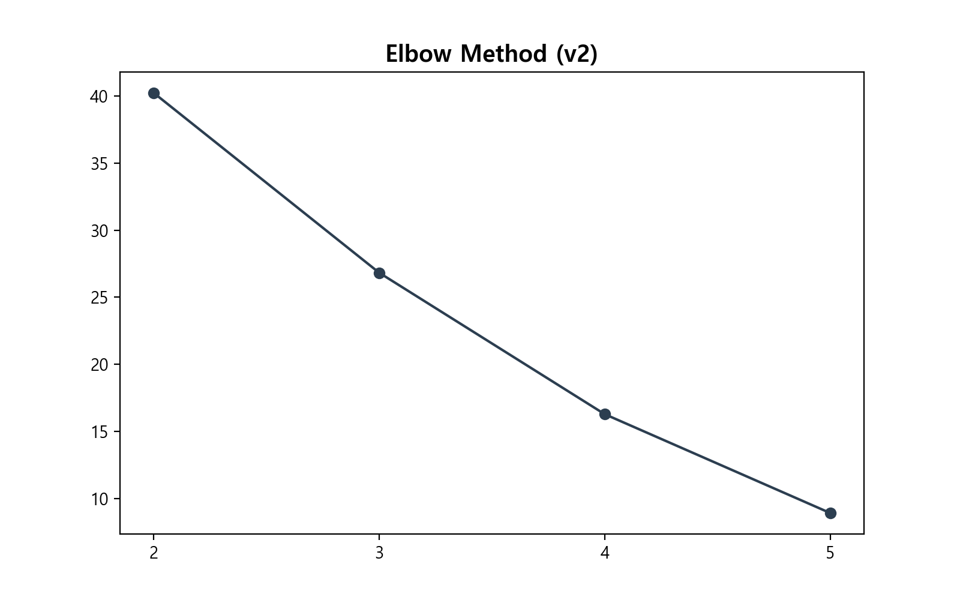
Figure 5. Elbow method for determining optimal number of clusters
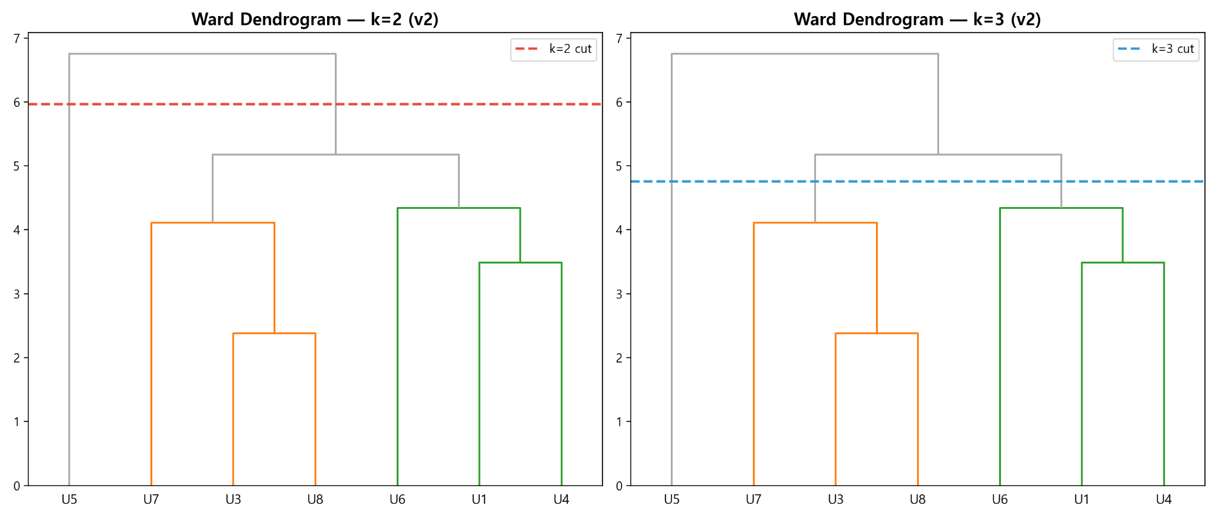
Figure 6. Ward dendrograms for k=2 (left) and k=3 (right), full sample
The steepest reduction in inertia occurred at k=3, suggesting that a three-cluster solution best captured the structure in the data. Ward dendrograms for k=2 and k=3 are shown in Figure 6. The k=3 solution produced three groups: {U3, U7, U8}, {U1, U4, U6}, and {U5}.
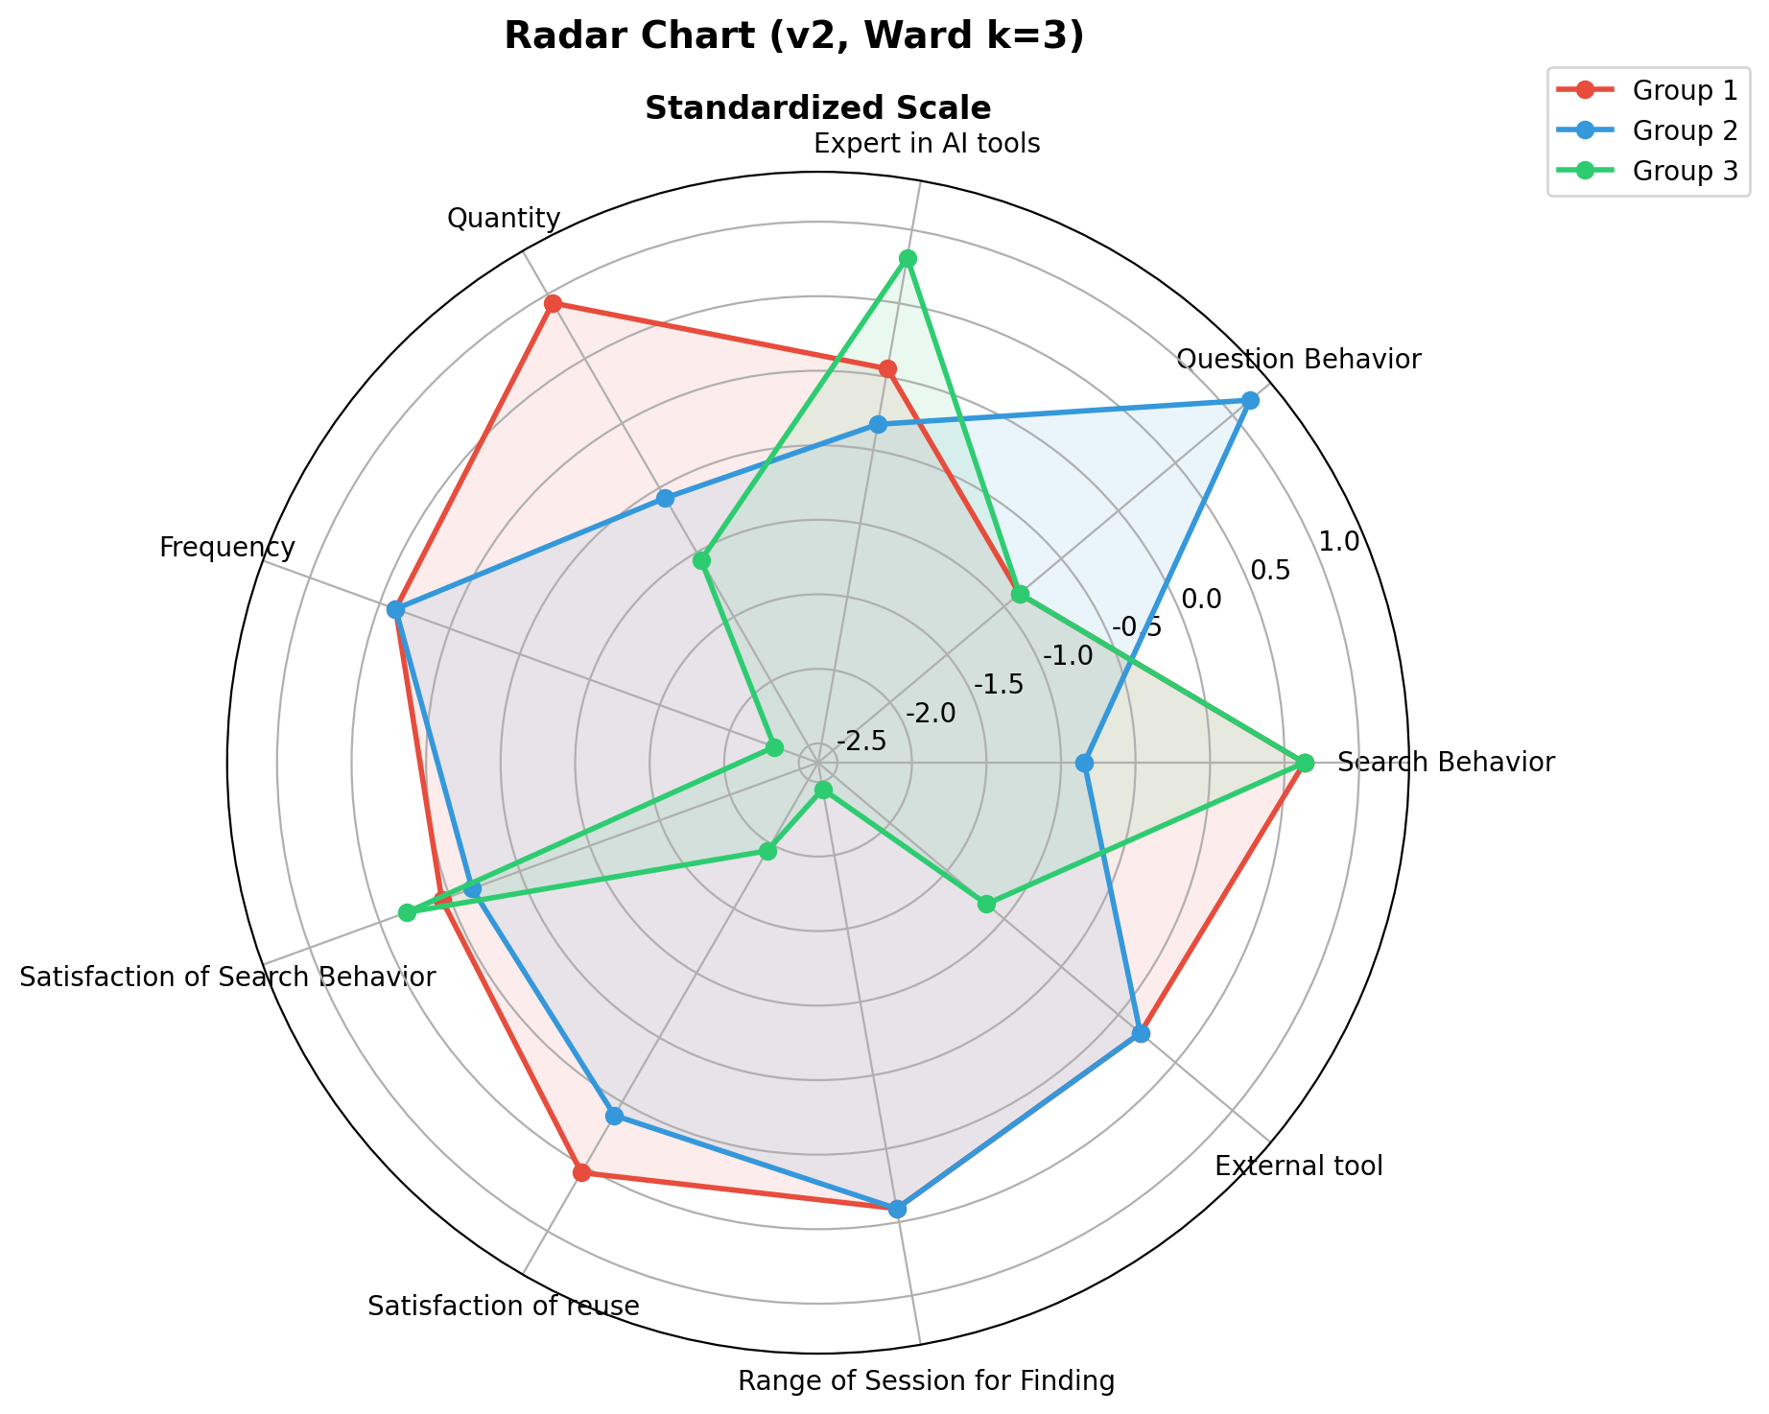
Figure 7. Radar chart comparison of three groups
Radar chart comparison of the three groups (Figure 7) revealed that U5 displayed a unique profile that was both close to the re-finding cluster in some features and diverged sharply from all other participants in others. Given the small sample size, this single-participant cluster was treated as an outlier rather than a stable user type. U5 was therefore excluded from subsequent analysis.
C. Final Clustering
Ward's hierarchical clustering was re-applied to the remaining six participants (U1, U3, U4, U6, U7, U8). Given that the sample size was reduced to six, a three-cluster solution repeatedly produced a single-participant cluster regardless of the linkage parameters. A two-cluster solution was therefore adopted as the most stable and interpretable outcome, yielding two groups: Group 1 ({U3, U7, U8}) and Group 2 ({U1, U4, U6}). The dendrograms for both k=2 and k=3 on the reduced sample are shown in Figure 8.
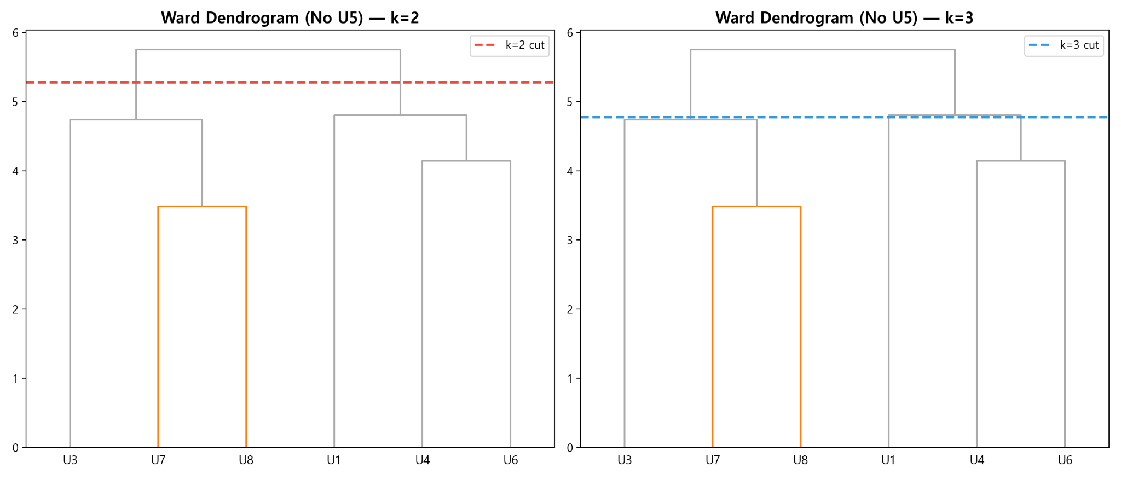Figure 8. Ward dendrograms for k=2 (left) and k=3 (right), excluding U5
To verify the meaningfulness of the two-cluster solution, we examined feature-level group differentiation. The standardized group profile heatmap and feature contribution analysis (Figure 9) showed that the most discriminating features were question type behavior, session quantity, AI tool proficiency, and re-finding behavior, in that order. Features such as re-finding frequency, external tool use, and search session scope contributed minimally to group separation, suggesting that the clustering was primarily driven by differences in how participants strategically managed past AI interactions rather than by usage volume alone.
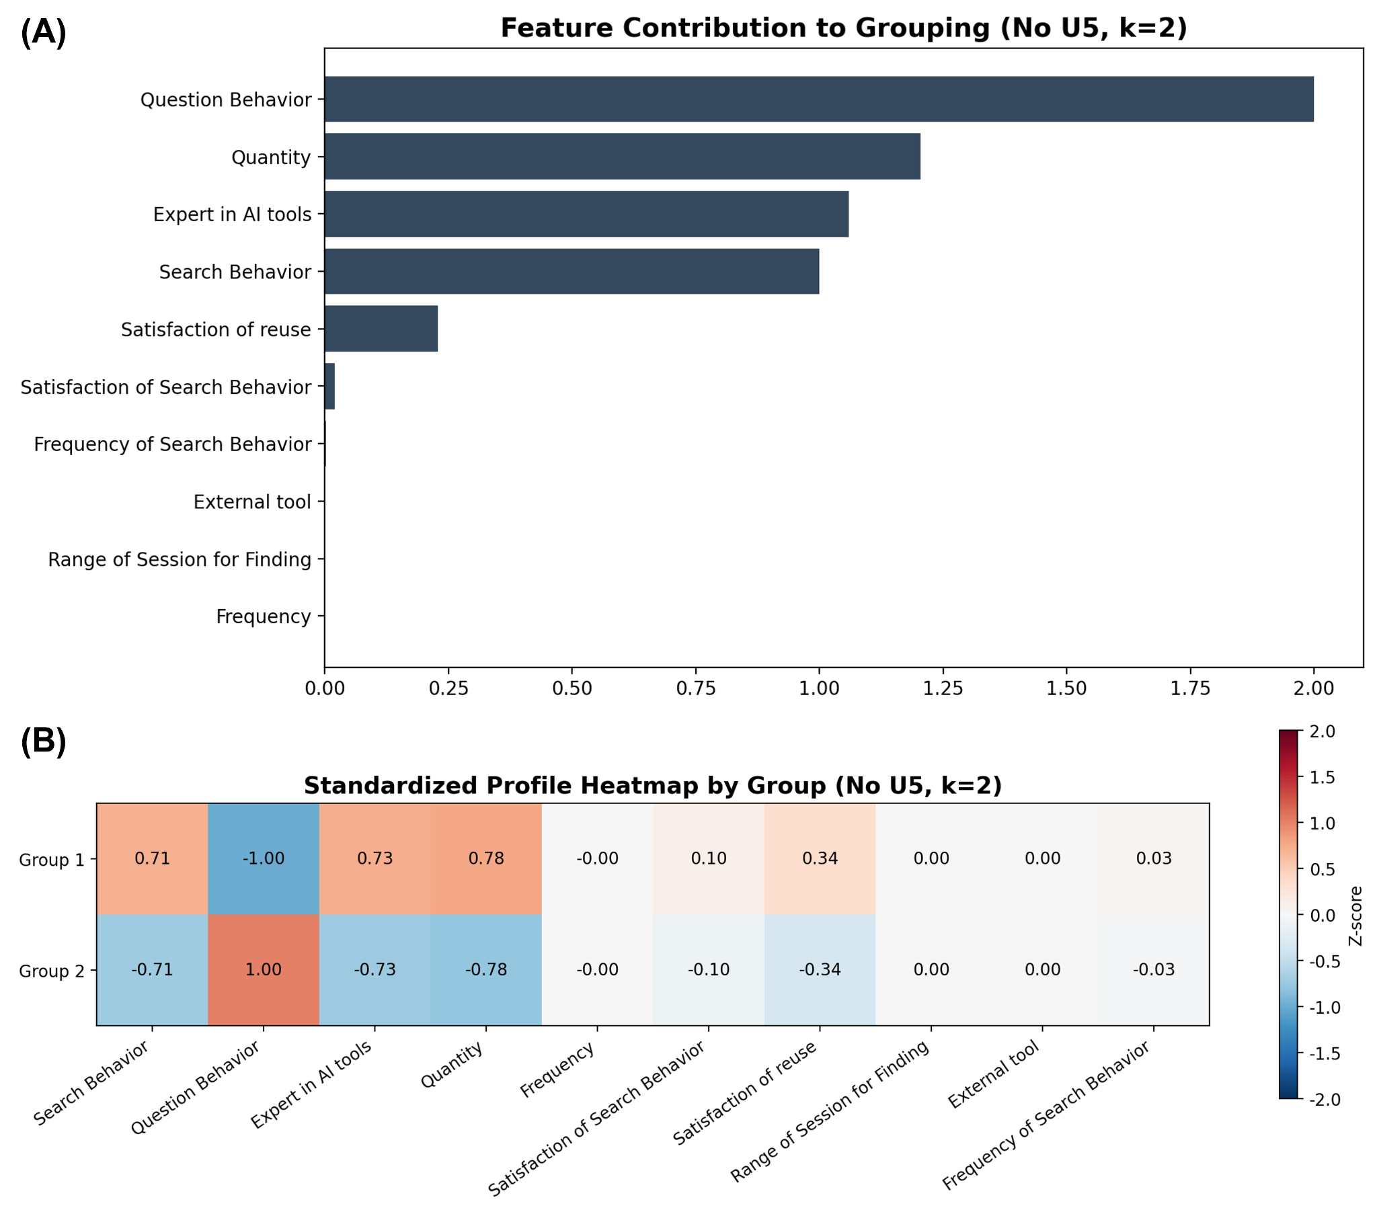
Figure 9. (A) Feature contribution to grouping and (B) standardized profile heatmap, k=2
D. Group Characterization
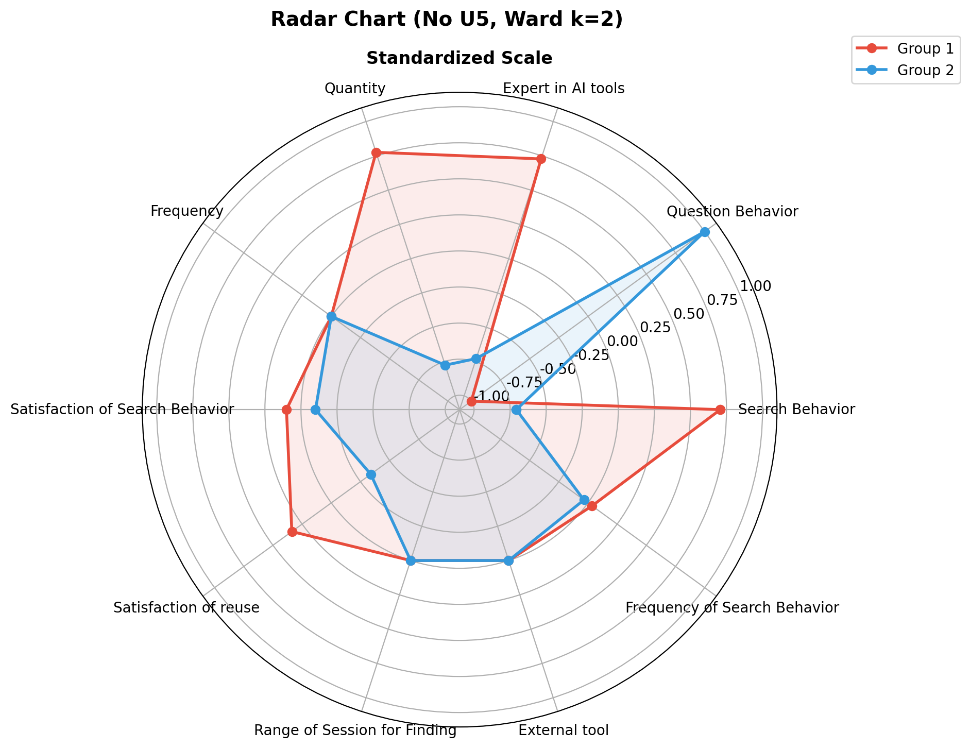
Figure 10. Radar chart comparison of two final groups
Radar chart comparison of the two final groups (Figure 10) revealed distinct behavioral profiles. Group 1 (U3, U7, U8) showed notably higher re-finding behavior scores and higher re-finding and reuse satisfaction, alongside elevated session quantity and usage frequency. Group 2 (U1, U4, U6) showed the opposite pattern: question type behavior was dominant, while re-finding behavior was relatively low, and overall satisfaction scores were somewhat lower.
Based on these profiles, Group 1 was designated as the Search type and Group 2 as the Question type. The Search type treats prior AI responses as reusable knowledge resources and actively attempts to locate them through search, scrolling, or Cmd+F. The Question type tends to bypass retrieval by re-prompting the AI, using re-question as a practical workaround when the original answer is difficult to locate or when the current context has become too long or noisy.
These two types should not be interpreted as fixed user categories. The same individual may shift between strategies depending on task urgency, available time, memory cues, and the perceived value of preserving prior context. Nevertheless, the distinction captures two structurally different orientations toward past AI-generated information, each of which implies different design requirements: the Search type requires better retrieval and reorientation support, while the Question type requires better context reconstruction and selective context control.

3.3. Customer Journey Map
To further illustrate how these behavioral differences manifest across a realistic workflow, we developed separate customer journey maps for each user type. To illustrate how the two identified user types experience re-finding in practice, we developed separate customer journey maps for the Search type and the Question type. Both maps trace users' actions, goals, emotions, pain points, and potential solutions across four stages of a typical research workflow: Literature Review, Conceptual Study, Proposal Writing, and Building a Prototype. These maps were constructed based on patterns observed during the interviews and observation sessions.

3.3.1. Search Type Journey
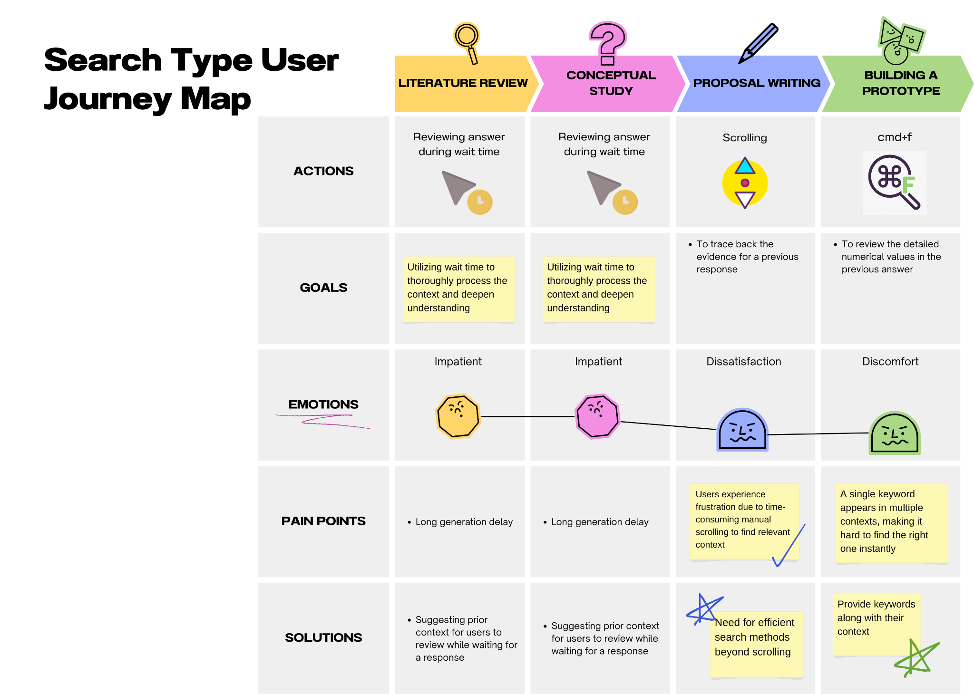
Figure 11. Search type user journey map
The Search type user enters the workflow with a proactive orientation toward reviewing and retaining AI-generated content. During the Literature Review and Conceptual Study stages, this user tends to review AI responses during wait time, using the idle period between prompt submission and response generation as an opportunity to process prior context and deepen understanding. Although this behavior reflects a deliberate strategy, the long generation delay during both early stages produces a persistent sense of impatience. As the workflow progresses into Proposal Writing, the user attempts to trace back evidence from a previous response by scrolling through long conversation histories. This stage is marked by dissatisfaction, as time-consuming manual scrolling makes it difficult to efficiently locate the relevant context. In the final stage of Building a Prototype, the user resorts to Cmd+F as a workaround to find specific numerical values or details from earlier answers. However, because a single keyword often appears across multiple contexts within the same session, this strategy produces discomfort rather than resolution. Across the journey, the Search type's pain points center on generation latency in early stages and inadequate in-session navigation support in later stages. The corresponding solution directions include surfacing prior context during wait time and providing keyword search with contextual disambiguation.

3.3.2. Question Type Journey
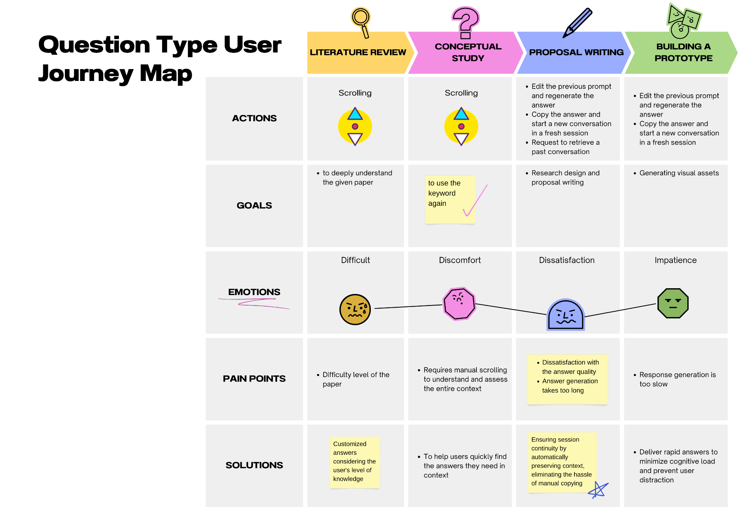
Figure 12. Question type user journey map
The Question type user approaches the same workflow with a different strategy, prioritizing task continuation over context preservation. During the Literature Review stage, this user relies on scrolling to navigate AI responses, which proves difficult given the complexity of the material. In the Conceptual Study stage, the user's primary goal is to reuse a keyword from a prior response, but the lack of efficient navigation tools requires manual scrolling through the entire conversation to locate it, resulting in discomfort. As the workflow moves into Proposal Writing, the user shifts toward more active re-finding strategies, including editing previous prompts to regenerate answers, copying outputs to start fresh sessions, or explicitly requesting retrieval of a past conversation. Despite these efforts, dissatisfaction arises from answer quality variability and slow generation times. In the Building a Prototype stage, the same pattern of editing prompts and copying outputs continues, but growing impatience reflects the cumulative cost of repeated regeneration. The Question type's pain points thus center on the absence of contextual retrieval support and the inefficiency of response generation under accumulated memory load. The corresponding solution directions include helping users quickly locate needed answers within context, ensuring session continuity through automatic context preservation, and delivering faster responses to reduce cognitive load.

3.4. Context Analysis
This user study was conducted with eight student researchers. The analysis showed that re-finding was not merely a repetitive behavior, but a core interaction practice embedded in student researchers’ broader work processes. Rather than consuming AI-generated outputs as one-off answers, participants repeatedly referred back to and reused them in subsequent tasks such as writing documents, revising code, conducting data analysis, and organizing materials.
As identified in Section 3.2, re-finding behavior was primarily expressed through two modes: search type and question type. The following analysis examines how contextual factors shape the choice between these two modes. Accordingly, this study analyzes re-finding across three layers of context—physical, social, and cultural context—with a particular focus on temporal, spatial, and other factors within each layer.

3.4.1. Physical Context
Re-finding behavior in the physical context is shaped by the temporal structure of work, the spatial configuration of the work environment, and the cognitive cost structure associated with different interaction modes.
From the perspective of the temporal factor, student researchers’ work rarely ends in a single step. Instead, it tends to accumulate and expand across multiple stages. AI-generated outputs are repeatedly referenced in subsequent tasks, which makes re-finding a recurring part of the workflow whenever information needs to be revisited, verified, or extended. In this process, search type is advantageous for preserving and reusing prior context, but it also requires time to navigate earlier conversations and reconstruct the relevant context. By contrast, re-question allows users to obtain a new result immediately through a new prompt, and is therefore more likely to be perceived as efficient under time pressure. Search type thus tends to be favored in longer-term work trajectories, whereas question type is more likely to be selected in situations that demand immediate progress.
The spatial factor becomes visible in the fact that student researchers’ work is not confined to a single screen or a single interface. Observations showed that most participants worked in environments with dual monitors or more, reflecting the nature of research work, which requires them to consult many resources simultaneously, including the AI conversation window, paper PDFs, code editors, web browsers, Notion, Google Docs, and LaTeX. In the experimental setting, physical constraints often led participants to split the screen or arrange multiple windows in parallel, suggesting that the spatial organization of the workspace itself can influence how users interact with conversational AI. As a result, re-finding was not limited to browsing conversation history within the AI interface. It also extended to revisiting outputs saved in external tools and reusing prior materials across distributed information spaces. In this sense, search type was not simply an in-UI function, but an activity distributed across the broader work environment.
The other factors in the physical context concern differences in cognitive burden between the two re-finding modes. Search type imposes a relatively high navigation cost because users must remember where a prior response appeared and recontextualize it within the current task. Re-question, by contrast, may feel more intuitive at the input stage, but it introduces a different burden: users must read, evaluate, and compare a newly generated response against prior outputs. The distinction between the two modes, therefore, is not merely a matter of feature familiarity, but is shaped by different cognitive cost structures associated with navigating versus regenerating information.

3.4.2. Social Context
In the social context, re-finding behavior is influenced by the roles and responsibilities assigned to student researchers, as well as by broader temporal and social conditions surrounding their work.
From the perspective of the temporal factor, student researchers are affected by a range of external schedules, including assignment deadlines, presentation preparation, and responses to advisor feedback. These temporal structures directly shape how re-finding is carried out. Under tight time constraints, participants were more likely to generate a new response through question type rather than spend time revisiting and reviewing prior conversations. When relatively more time was available, the search type strategy was more often used to preserve and revisit existing context. This tendency also appeared in the time-limited observation sessions, where participants increasingly shifted toward question type as the available time decreased.
The spatial factor in the social context is related to the social environments in which work takes place. Spaces such as laboratories, seminar rooms, homes, and cafés are not simply physical settings, but environments that shape whether users are working alone, interacting with others, or responding to immediate demands. For example, in shared environments or situations that require a quick response, re-question may be preferred because it enables rapid result generation. By contrast, in more stable individual work settings, re-searching may be more feasible because users can revisit prior records more deliberately and with fewer interruptions.
The other factors in the social context are closely tied to the responsibility of verification. Participants did not simply accept AI outputs at face value; instead, they repeatedly checked, questioned, and verified the generated information. This made re-finding more than a matter of convenience. It functioned as a necessary practice for securing the reliability of information. Seen in this light, the difference between search type and question type was not simply a matter of personal preference, but an interaction strategy shaped by social responsibility and work demands.

3.4.3. Cultural Context
Within the cultural context, re-finding behavior varies depending on how users perceive uncertainty, how they seek control, and how they form expectations and trust toward AI systems.
From the perspective of the temporal factor, contemporary AI use is shaped by simultaneous expectations for both speed and accuracy. However, the perception that the same prompt may not always reproduce the same quality of output led some users to regard re-searching as the more stable option. At the same time, the expectation that a new prompt might yield a better response encouraged others to rely on re-question.
The spatial factor in the cultural context appears in differences in how information is organized and managed. Some users maintained a single session in order to accumulate and track context in one place, whereas others separated conversations by topic in order to reduce context contamination. This distinction is less about physical space than about different ways of structuring and handling information.
The other factors relate to attitudes toward uncertainty avoidance and controllability. Users who preferred search type tended to regard revisiting previously obtained results as more stable and predictable. Users who preferred re-question, by contrast, tended to expect that asking again could produce a better answer. Interestingly, those who relied on search type reported higher satisfaction with reusing prior results, whereas those who relied on re-question showed relatively lower satisfaction because of the variability of regenerated outputs. This suggests that reusing information within preserved context may offer greater value than relying on the uncertain payoff of newly generated results.
Overall, the difference observed in the cultural context can be understood as the outcome of different strategies chosen under a shared goal: reducing uncertainty while maintaining a sense of control.

3.5. Persona Analysis
Based on the recurring behavioral patterns identified through user clustering and further interpreted through contextual analysis, we developed two representative personas. These personas synthesize recurring goals, contexts of use, pain points, and needs observed across participants. Figure 13 represents the two representative personas.

3.5.1. Persona 1: Minjae, the Question-oriented User
Minjae represents users who primarily treat conversational AI as a fast problem-solving tool. Rather than spending time locating an earlier answer, this type of user tends to ask again in order to quickly regenerate the needed information and continue the current task. This tendency becomes more prominent when the user is under time pressure or when immediate progress is valued more than preserving prior context. However, this strategy also brings difficulties. Because regenerated answers may differ in wording, scope, or quality, these users often experience lower satisfaction and reduced confidence in the consistency of the output. Accordingly, their main needs include quick continuation support, better control over which prior context is referenced when asking follow-up questions, and lightweight ways to compare newly generated answers with previous ones when needed.

3.5.2. Persona 2: Jieun, the Search-oriented User
Jieun represents users who regard previous AI responses as valuable work resources that should be revisited and reused rather than replaced. This type of user is more likely to search for an earlier session or answer, especially when the task requires careful verification, continuity of reasoning, or reuse of prior outputs in later work. These users place importance on preserving surrounding context, such as the original prompt, adjacent responses, or the location of the answer within a session. Their main difficulties arise when sessions are hard to distinguish, search results are too broad, or the exact response location is difficult to recover. Accordingly, their main needs include more fine-grained search support, stronger reorientation within sessions, and context-preserving retrieval mechanisms that make old answers easier to interpret and reuse.

3.5.3. Comparison of Two Representative Personas
The two personas differ not simply in preference, but in how they manage uncertainty, effort, and continuity during knowledge work with conversational AI. The question-oriented persona prioritizes speed and task continuation, often choosing to ask again instead of spending time locating an older answer. By contrast, the search-oriented persona places greater value on preserving, revisiting, and reusing previously generated answers within their original context. This distinction reflects the broader contextual findings of the study, in which re-question was often associated with immediate progress under time pressure, whereas search type was more closely tied to verification, contextual reconstruction, and longer-term work continuity.
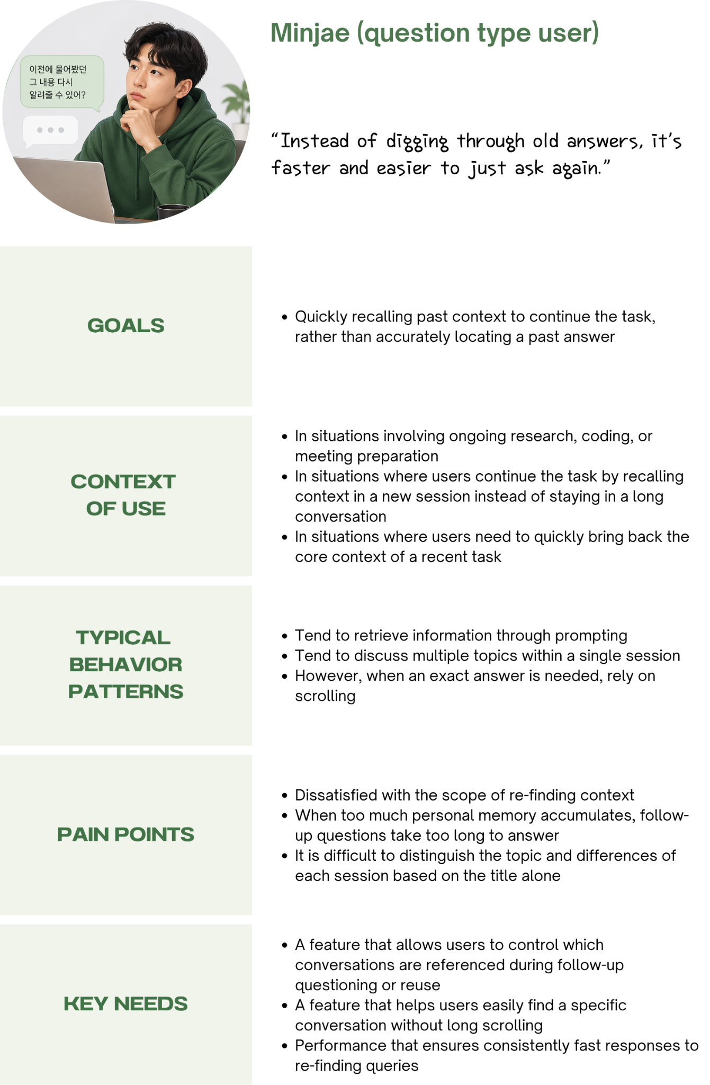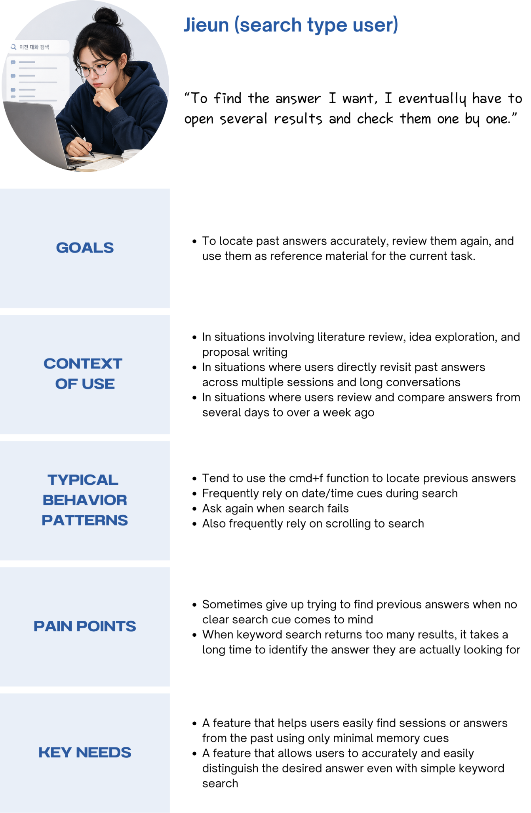
Figure 13. Two representative personas identified from the study

3.5. Function Analysis
Based on the user classification, interview findings, and observation results, we conducted a function analysis to identify the core functions required to support re-finding and reuse of past AI conversations. The analysis began with the pain points and needs identified from the two user types: the search type and the question type. These pain points were then translated into use cases, requirement candidates, and finally a smaller set of core functions.
The highest-level function of the proposed system is to support re-finding and reuse of past AI conversations. Figure 14 presents the overall function diagram of the system. The system receives three types of inputs: energy inputs, material inputs, and signal/status inputs. Energy inputs include computational resources and power. Material inputs include past conversation history, session metadata, and personal memory. Signal/status inputs include search conditions, the current query, and the selected reference scope. Through the proposed functions, the system produces outputs such as retrieved answer data, reusable past conversation data, improved response speed and processing efficiency, task reuse status, and context reconstruction status.

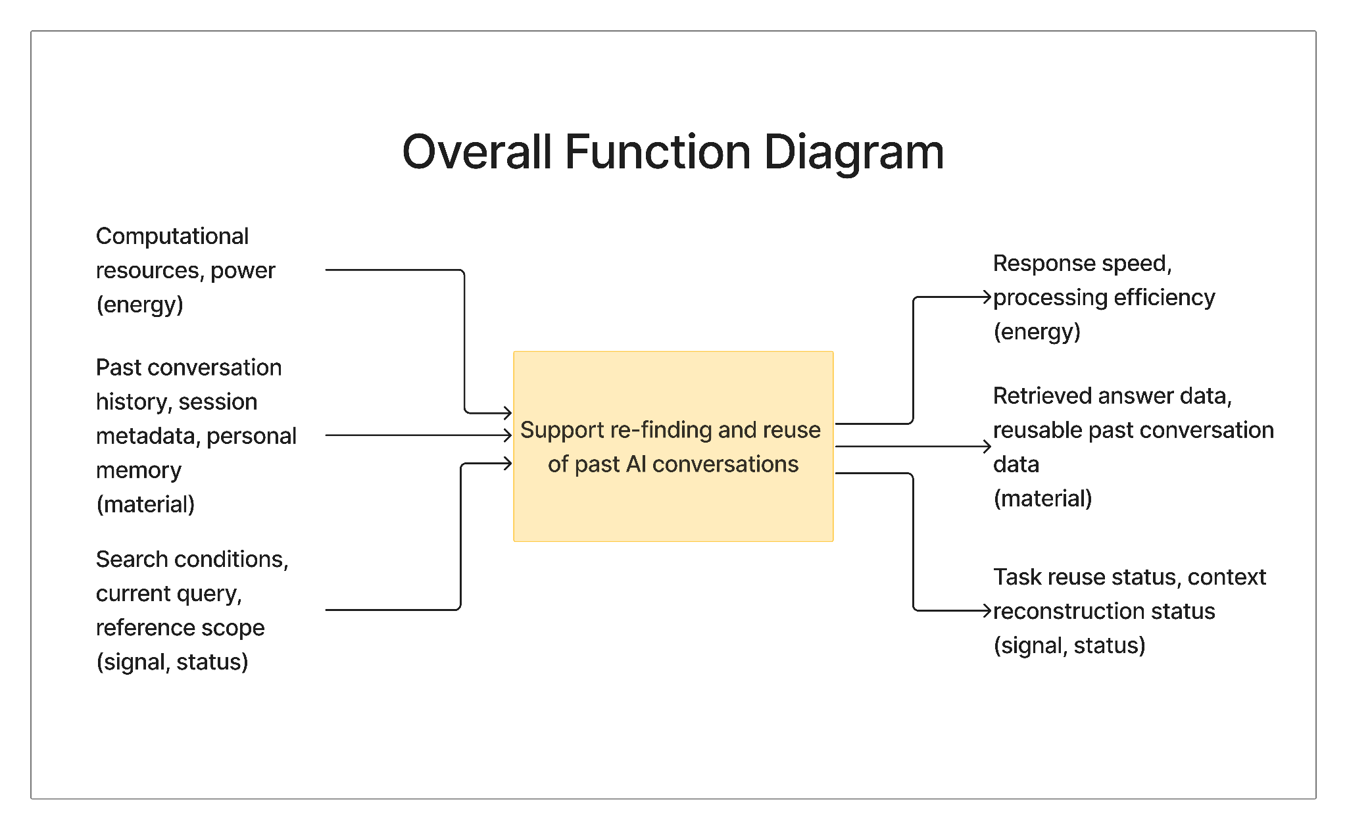
Figure 14. Overall function diagram.
The purpose of this function analysis is not simply to list interface features, but to clarify how user needs are transformed into system-level functions. Therefore, we organized the analysis in two steps. First, we identified the key functions derived from the user needs and requirement candidates. Second, we analyzed the structural relationships between these functions to show how they work together in the re-finding and reuse process.

3.5.1. Key Functions
The key functions were derived through a structured analysis that moved from pain points to use cases, from use cases to requirement candidates, and finally from requirement candidates to core functions.
A. Pain Points and User Needs
Based on the affinity-based analysis described in Section 2.4, we identified six pain points distributed across the two user groups and one shared pain point common to both. The search type reported two primary difficulties. First, they found that retrieval cues become too weak to reconstruct over time, as memory for specific keywords, titles, and contextual details fades after one to two weeks. Second, even when a relevant keyword is entered, search results within a single thread return too many similar-looking matches, making it difficult to distinguish the target response from adjacent ones. The question type reported three distinct pain points. First, the reference scope of the system during re-question felt uncontrollable—sometimes pulling in too much irrelevant past context, sometimes excluding context the user intended to reuse. Second, navigating back to a specific point within a long conversation required excessive scrolling, as there was no mechanism to jump directly to a remembered location. Third, when personal memory accumulated over time, re-question became slower because the system processed large amounts of accumulated context even when only a narrow portion was relevant to the current task. Finally, both user types shared a common difficulty: automatically generated session titles were too similar to one another, making it hard to distinguish sessions at a glance when browsing or searching across multiple conversations.
These pain points were translated into user needs in relation to the situational contexts in which they arose. Table 6 summarizes the six pain points along with their core causes, situational contexts, and the corresponding user needs.
Table 6. Summary of pain points, core reasons, and user needs by user group
User Group | Pain Point | Core Reason | Situational Context | User Need
Search type | Retrieval cues are too weak to reconstruct | Memory for specific details fades over time | Attempting to retrieve a conversation from one to two weeks ago | Users want to re-find old conversations with minimal memory cues
Search type | Keyword search returns too many similar results | Similar expressions repeat and accumulate within a thread | Searching within a thread where the same topic recurs across multiple turns | Users want to distinguish the target response from similar results using contextual cues
Question type | Reference scope during re-questioning feels uncontrollable | Users cannot directly adjust the system's reference range | When only a specific portion of past context is relevant to the current question | Users want to selectively control which past context is referenced in a new question
Question type | Scrolling through long conversations is excessive | The exact location of a past response is difficult to identify or recall in a long session | When a user already knows roughly where a target response is but cannot reach it efficiently | Users want to jump directly to a specific point in a long conversation without scrolling
Question type | re-question becomes slow when personal memory is large | Accumulated personal memory causes the system to process a large amount of context even for narrow queries | When posing a follow-up question under heavy personal memory load | Users want fast responses even when the system has access to a large amount of accumulated context
Both groups | Session titles are too similar to distinguish | Automatically generated titles reflect only the first message and do not differentiate sessions that share a topic | When browsing session lists or reviewing search results that contain multiple similarly titled sessions | Users want to identify the correct session based on title alone
B. Use Cases
From these six pain points and needs, we constructed six use cases that represent the distinct interaction scenarios in which re-finding and reuse difficulties arise. Each use case specifies the participating actor, the triggering condition, the main flow of events, exit conditions, and quality requirements. The six use cases are as follows: UC1 (Re-find an old conversation) addresses the search type's difficulty with weak retrieval cues across multiple sessions; UC2 (Disambiguate similar results within a thread) addresses the problem of excessive and indistinguishable keyword search results; UC3 (Jump to a specific point in a long conversation) addresses the excessive scrolling burden faced by the question type; UC4 (Reuse past context in a new question) addresses the inability to control which prior context is referenced; UC5 (Ask a follow-up question under heavy personal memory load) addresses response latency caused by large accumulated memory; and UC6 (Identify the correct session among similarly titled sessions) addresses the shared difficulty of session disambiguation. Table 7 summarizes the key components of each use case.
Table 7. Summary of use cases derived from user pain points and needs.
 | UC1 | UC2 | UC3 | UC4 | UC5 | UC6
Name | Re-find an old conversation | Disambiguate similar results within a thread | Jump to a specific point in a long conversation | Reuse past context in a new question | Ask a follow-up question under heavy personal memory load | Identify the correct session among similarly titled sessions
Actor | Search type | Search type | Question type | Question type | Question type | Both types
Brief description | The user locates a past conversation from days or weeks ago and resumes work from that point. | The user identifies the exact target response when similar expressions recur within a single thread. | The user quickly re-enters the location of a needed response within an already-found session. | The user continues a new question by selectively reusing context from past work, controlling which sessions are referenced. | The user asks follow-up questions efficiently while the system holds a large amount of accumulated personal memory. | The user identifies the intended session from a list of similarly titled sessions.
Entry condition | Past conversation records exist; the user remembers only an approximate topic or task context. | A long thread contains repeated conversations on the same topic; the user wants to revisit a specific response or segment. | The target session has already been found; the session is long with many messages. | Multiple sessions or long conversation contexts exist; the user wants only a specific portion of past context reflected. | A large amount of personal memory or accumulated user context is stored in the service. | Multiple sessions on the same topic exist; automatically generated titles are similar to each other.
Exit condition | The user finds the past conversation and resumes work, or switches to re-questioning when the conversation cannot be found. | The user accurately identifies the target response, or switches to manual browsing when results cannot be distinguished. | The user re-enters the needed response location, or spends excessive time navigating within the session. | The user receives a response reflecting only the desired context, or repeats input due to failed context control. | The user continues follow-up questions while leveraging personal context, or abandons context use due to response latency. | The user identifies the target session, or spends additional time and effort in repeated browsing.
Quality requirements | Must surface relevant conversations with minimal memory cues; cognitive load for result discrimination must be low. | Must provide surrounding context snippets alongside similar results; must reduce confusion from excessive result exposure. | Must minimize navigation time even in long sessions; must allow users to reach the target point without excessive scrolling. | Users must be able to clearly control the reference context range; unnecessary context mixing must be minimized. | Response latency must not increase excessively even when personal memory is large; only relevant memory should be selectively reflected. | Sufficient distinguishing cues must be provided beyond session titles; session identification time must be short.
C. Requirement Candidates and Consolidation
From the six use cases, we extracted a total of 20 requirement candidates covering functional requirements, interface requirements, qualitative requirements, and design constraints. Overlapping requirements that appeared across multiple use cases were consolidated. For example, the need for semantic search support appeared in both UC1 and UC2, and requirements related to reference scope control appeared in both UC4 and UC5. After consolidation, the 20 requirements were grouped by their shared underlying capability to form a smaller set of core functions. Table 8 presents the consolidated requirement set with type classifications and use case mappings.
Table 8. Consolidated system requirements derived from use cases.
ID | Requirement | Type | Related Use Cases
R1 | The system shall support meaning-based search so that users can locate relevant past conversations without needing exact keywords. | Functional | UC1, UC2
R2 | The system shall display additional identification cues beyond the session title, including date, last modified time, and a short summary or preview. | Interface | UC1, UC2, UC6
R3 | The system shall present contextual snippets surrounding search results to support result discrimination. | Interface | UC2, UC4
R4 | The system shall support relevance-based sorting and result grouping when search results are numerous. | Functional | UC2
R5 | The system shall allow users to jump directly to a specific message or response location within a session. | Functional | UC2, UC3
R6 | The system shall highlight the location of a jumped-to or searched result within the conversation view. | Interface | UC3
R7 | The system shall present long conversations in structured segments or sections. | Functional | UC3
R8 | The system shall provide section summaries or a table of contents for long conversations. | Interface | UC3
R9 | The system shall allow users to select the range of sessions or context to reference when posing a new question. | Functional | UC4, UC5
R10 | The system shall make explicit which past conversations or memory items are being referenced for the current response. | Interface | UC4, UC5
R11 | The system shall allow users to exclude unwanted context from being referenced. | Functional | UC4
R12 | The system shall support automatic summarization of selected past context for reuse in a new question. | Functional | UC4, UC5
R13 | The system shall support selective or summarized reference to personal memory rather than full retrieval. | Functional | UC5
R14 | The system shall not introduce excessive response latency when personal memory is accessed. | Qualitative | UC5
R15 | The system shall allow users to manually edit or pin session titles. | Functional | UC6
R16 | The system shall support grouping or sorting of sessions to distinguish similarly titled conversations. | Functional | UC1, UC6
R17 | The system shall present results and reduce cognitive load even when retrieval cues are minimal. | Qualitative | UC1, UC2, UC3
R18 | The system shall allow users to continue follow-up work immediately after re-finding a relevant response. | Functional | UC1, UC4, UC5
R19 | The system shall integrate re-finding and reuse features without significantly increasing interaction complexity. | Design constraint | All
R20 | The system shall prioritize contextually relevant information and avoid retrieving excessive or unrelated past context. | Qualitative | UC4, UC5
D. Core Functions
The 20 requirements were further grouped by their common underlying capability, yielding three core functions. Requirements addressing retrieval and session identification (R1, R2, R3, R4, R15, R16, R17) were consolidated into a single function: Retrieve target conversation or keyword, which covers semantic search, result disambiguation, and session-level identification. Requirements related to in-session navigation, context selection, and scope control (R5, R6, R7, R8, R9, R10, R11, R20) were consolidated into Reconstruct relevant context, which covers positional re-entry, context range selection, and irrelevant context exclusion. Finally, requirements supporting seamless continuation of work after retrieval (R12, R13, R14, R18, R19) were consolidated into Continue work efficiently, which covers context summarization for reuse, memory management, response speed, and interaction continuity. These three core functions form the functional backbone of the proposed system and are elaborated further in Section 3.4.2.
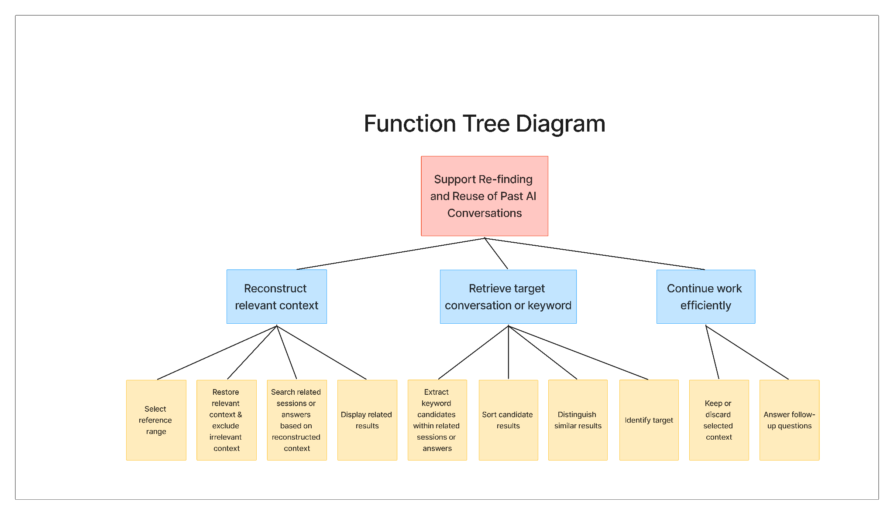
Figure 15. Function tree diagram.

3.5.2. Structural Relationships Between Functions
The identified functions are organized around the highest-level goal of supporting the re-finding and reuse of past AI conversations. The function analysis produced three complementary diagrams: an overall function diagram, a function flow diagram, and a function tree diagram. The overall function diagram defines the system boundary by specifying the major inputs and outputs. The function flow diagram describes how sub-functions are connected in sequence, while the function tree diagram organizes the same functions into a hierarchical structure.
At the highest level, the system receives three types of inputs: energy inputs, material inputs, and signal/status inputs. Energy inputs include computational resources and power required to process the request. Material inputs include past conversation histories, session metadata, and personal memory. Signal/status inputs include the user’s search condition, current question, and selected reference range. The system then produces outputs such as retrieved answer data, reusable previous conversation data, improved response efficiency, and the status of whether the previous conversational context has been restored.
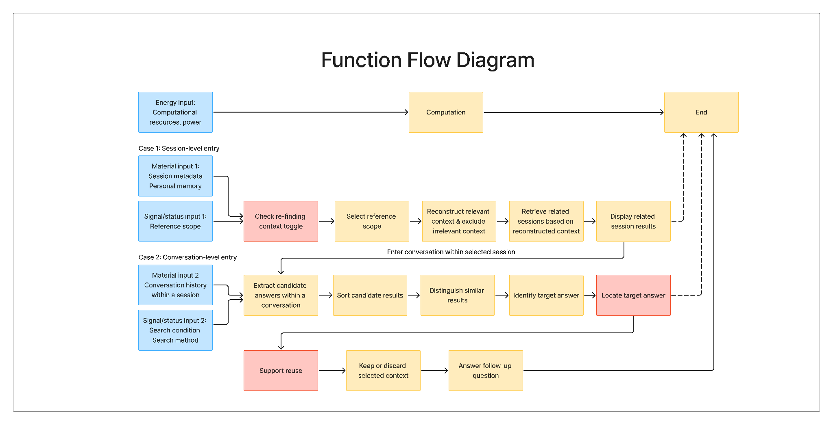
Figure 16. Function flow diagram.
The core functional structure consists of three major functions. First, the system must reconstruct relevant context by allowing the user to select a reference range and by restoring useful context while excluding irrelevant context. Second, the system must retrieve the target session or answer by searching related sessions or answers, displaying candidate results, extracting relevant keyword candidates, sorting candidate results, distinguishing similar results, and helping the user identify the target answer. Third, the system must continue the user’s work efficiently by allowing the user to keep or discard the selected context and continue with follow-up questions.
These functions are sequentially related but also mutually dependent. Context reconstruction precedes retrieval because the system needs to know which range of past conversations should be considered before searching. Retrieval then narrows the candidate space and helps the user identify the target answer. Finally, workflow continuation connects the retrieved answer back to the current task by supporting follow-up interaction based on the selected context. Therefore, the functional relationship can be summarized as:
select reference range → reconstruct relevant context → retrieve target session or answer → identify target answer → continue work with selected context
This structure also reflects the two user strategies identified in the user classification. For the search type, the most important functions are retrieving target sessions or answers and distinguishing similar results. For the question type, the most important functions are reconstructing relevant context and controlling whether the selected context should be carried over or discarded. Thus, the structural relationship between functions was designed to support both direct re-finding and context-based re-question.

References
Thorndike, R. L. (1953). Who belongs in the family?. Psychometrika, 18(4), 267-276.
Ward, J. H. (1963). Hierarchical grouping to optimize an objective function. Journal of the American Statistical Association, 58, 236–244.

Appendices

A. Interview Form
The appendix retains the original wording of the prompt, including the term thread. However, following the user interviews, we determined that session was a more appropriate term and therefore standardized the term as session throughout the main report. Below are the full interview questions used in our semi-structured interview.

A.1. End User Interview Form
[Introduction]
안녕하세요. 인터뷰에 응해주셔서 감사합니다. 저희 인터뷰는 대화형 AI 사용 경험, 특히 예전 대화를 다시 찾거나 활용하는 경험을 이해하기 위한 사용자 인터뷰입니다. 정답은 없고, 실제 있었던 경험을 편하게 말씀 부탁드립니다. (Hello, thank you for participating in this interview. This interview is intended to understand users’ experiences with conversational AI services, particularly their experiences of revisiting and reusing past conversations. There are no right or wrong answers, so please feel free to share your actual experiences.)
[Screening / User Profile]
Q1. OO님의 나이와, 직업, 전공, 연구분야에 관해 간략히 소개 가능하신가요? (Could you briefly introduce yourself in terms of your age, occupation, major, and research area?)
Q2. 평소 어떤 대화형 AI 서비스를 주로 사용하시나요? 유료 버전인가요, 무료 버전인가요? (가이드 예시: ChatGPT, Claude, Gemini, Cursor 등) (Which conversational AI services do you mainly use in your daily life? Are they paid or free versions? (Guide examples: ChatGPT, Claude, Gemini, Cursor, etc.))
Q3. 이런 서비스를 주에 몇 회, 하루에 몇 시간 정도 사용하시나요? (가이드 예시: 거의 매일 / 주 몇 회 / 가끔) (How often do you use these services per week, and for about how many hours per day (Guide examples: almost every day / several times a week / occasionally))
Q4. 주로 어떤 용도로 사용하시나요? (가이드 예시: 공부, 연구, 코딩, 글쓰기, 정보 탐색, 번역 등) (What do you mainly use them for? (Guide examples: studying, research, coding, writing, information seeking, translation, etc.))
Q5. 대화를 사용하는 방식은 어떤 편인가요? (How do you usually manage or structure your conversations with these services?)
Q5-1. 한 스레드를 길게 이어가는 편인가요, 아니면 새 대화를 자주 여는 편인가요? (Do you tend to continue one thread for a long time, or do you frequently start new conversations?)
Q5-2. 스레드를 사용하신다면 스레드 제목을 변경하시나요? (If you use threads, do you change or edit the thread titles?)
Q5-3. GPT나 Claude의 ‘프로젝트’ 기능이나 ‘새 채팅으로 브랜치’ 기능에 대해 알고 계신가요? (Are you familiar with features such as the “Projects” function in GPT or Claude, or the “branch into a new chat” function?)
Q5-3-1. (안다고 답하는 경우) 알고 계신다면 위와 같은 기능을 사용하시나요? ((If yes) If you know these features, do you actually use them?)
Q5-3-2. (안 쓴다고 답하는 경우) 안 쓰시는 이유가 있으신가요? ((If no) If you do not use them, is there a particular reason?)
Q6. 예전에 AI가 해준 답변이나 대화를 다시 찾아본 경험이 있으신가요? (Have you ever tried to revisit or look up a past AI response or conversation?)
Q6-1. 있었다면 얼마나 자주 있으셨나요? 주에 몇 회, 하루에 몇 번 정도였는지 기억하시나요? (If so, how often does this happen? Do you remember approximately how many times per week or per day?)
Q6-2. 같은 thread 안에서 찾는 경우가 많나요, 여러 thread를 넘나드는 경우가 많나요? (Do you usually search within the same thread, or across multiple threads?)
Q6-3. 평소에 AI답변 기록을 위해 메모앱, 노션, 북마크 같은 다른 툴을 섞어 쓰시나요? (Do you use any additional tools, such as memo apps, Notion, or bookmarks, to keep track of AI responses?)
[Refinding Case]
Q1. 보통 어떤 방식으로 예전 답변을 찾으시는지 과정을 설명해주실 수 있으신가요? (Could you describe the process you usually go through when trying to find a past response?)
Q1-1. 막혔던 부분이 있었다면, 가장 어려웠던 지점은 어디였나요? (If there was a point where you got stuck, what was the most difficult part?)
Q2. 가장 최근에는 어떤 답변을 다시 찾으려고 했나요? (What was the most recent response you tried to find again?)
Q3. 그 답변이나 대화가 왜 다시 필요했나요? 그 당시 어떤 작업이나 상황이었는지도 함께 말씀해주시면 좋습니다. (Why did you need that response or conversation again? It would also be helpful if you could describe the task or situation you were dealing with at that time.)
Q4. 그때는 어떤 방식으로 답변을 찾아가셨나요? 단어나 문장, 주제나 상황, 결과물 형태, 답변의 위치 등을 기준으로 설명해주셔도 됩니다. (How did you try to find the response at that time? You may explain in terms of specific words or phrases, topic or situation, output type, or the location of the response.)
Q5. 그 대화가 같은 thread 내에 있다고 생각했나요, 아니면 여러 thread 중 하나라고 생각했나요? (Did you think that conversation was within the same thread, or did you think it was in one of several threads?)
Q5-1. 최근 작업 중 다시 찾은 건가요, 아니면 한참 전 대화를 찾은 건가요? (Was it something from a recent task, or were you trying to find a much older conversation?)
Q5-2. 코드, 표, 요약, 설명 중 어떤 형태의 답변이었나요? (What form did the response take, for example, code, a table, a summary, or an explanation?)
Q5-3. 그 사례가 평소에도 자주 있는 유형인가요? (Is this the kind of situation that happens often for you?)
Q6. 결국 찾았나요? 찾았다면 얼마나 수월했는지, 못 찾았다면 어떻게 마무리했는지 말씀해 주세요. (Did you eventually find it? If you found it, please describe how easy or difficult it was. If you did not find it, please explain how you handled the situation.)
Q6-1. 검색어를 여러 번 바꾸셨나요? (Did you try changing the search terms multiple times?)
Q6-2. 결과가 너무 많았나요, 아니면 아예 나오지 않았나요? (Were there too many results, or did no relevant results appear?)
Q6-3. Thread는 찾았지만 답변의 정확한 위치를 찾지 못한 경우였나요? (Did you find the thread but fail to locate the exact response within it?)
Q6-4. 제목이나 날짜 같은 정보도 참고하셨나요? (Did you also refer to information such as the title or date?)
Q6-5. 못 찾았을 때는 새로 다시 질문하셨나요? (When you could not find it, did you end up asking the AI again from scratch?)
Q6-6. 위와 같은 행동을 하실 때는 어떤 생각이 드셨나요? (What were you thinking or feeling while going through those steps?)
Q7. 당시의 재탐색 과정에 대해 점수를 매긴다면 5점 만점 중 몇 점이라고 생각하시나요? 왜 그렇게 생각하시나요? (If you were to rate that re-finding process on a 5-point scale, what score would you give it, and why?)
[Reuse Case]
Q1. 답변은 찾았지만, 원래 질문이나 앞뒤 맥락을 같이 봐야 이해가 되는 경우가 있었나요? (Have there been cases where you found the response, but still needed to look at the original question or surrounding context in order to understand it?)
Q2. 찾은 답변을 이후 작업에 다시 활용하시거나 참고하시는 편인가요? (Do you tend to reuse or refer back to the responses you find in your later work?)
Q2-1. 그렇다면, 어떻게 활용하시나요? (If so, how do you use or reuse them?)
Q2-2. 예전 답변을 다시 쓰거나 참고할 때 불편했다면 무엇이었나요? (If reusing or referring to past responses felt inconvenient, what made it difficult?)
Q2-3. 찾긴 했지만 왜 그런 답이 나왔는지 바로 이해되지 않았던 적이 있으셨나요? (Have there been times when you found the response, but could not immediately understand why that answer had been generated?)
Q2-4. 다시 활용하는 과정에 대해 점수를 매긴다면 5점 만점 중 몇 점이라고 생각하시나요? 왜 그렇게 생각하시나요? (If you were to rate the reuse process on a 5-point scale, what score would you give it, and why?)
[Improvement Directions and Importance]
Q1. 앞서 이야기한 문제들 중에서 특히 개선되었으면 하는 부분이 있으신가요? (Among the issues we discussed, are there any aspects you would particularly like to see improved?)
Q2. 예전 AI 답변을 더 쉽게 다시 찾으려면 어떤 정보가 가장 도움이 될 것 같나요? (What kind of information do you think would be most helpful for finding past AI responses more easily?)
Q3. 재탐색 과정이 개선된다면 현재 작업 방식에서 어떤 점이 가장 달라질 것 같나요? 시간 측면, 작업 흐름, 재활용 가능성 등의 측면에서 자유롭게 말씀해주셔도 됩니다. (If the re-finding process were improved, what do you think would change the most in your current workflow? You may answer in terms of time, workflow, reusability, or any other aspect you find relevant.)
[Closing]
Q1. 혹시 보조 참관자분께서 추가로 질문하고 싶은 내용이 있으신가요? (Does the assistant observer have any additional questions to ask?)
Q2. 혹시 이러한 재탐색 경험이나 의견과 관련해 추가로 공유하고 싶으신 내용이 있으신가요? (Is there anything else you would like to share about your experiences or opinions regarding re-finding past AI conversations?)
네, 인터뷰는 여기까지입니다. 다시 한 번 시간 내주셔서 감사합니다. (That concludes the interview. Thank you again for your time.)

A.2.1. Service Provider (Product Manager)
[Background & Context]
Q1. 현재/과거 Conversational AI 서비스에서 담당하고 계신 구체적인 역할은 무엇인가요? (What specific role have you been responsible for in current or past conversational AI services?)
Q2. Conversational AI 시스템에서 기획 및 운영의 담당 범위는 어디까지인가요? (What is the scope of your responsibilities in planning and operating a conversational AI system?)
Q3. Conversational AI 시스템에서 기능 중 어떤 기능을 가장 밀접하게 관리하고 계신가요? (Which functions in the conversational AI system have you been most closely involved in managing?)
[Problem Recognition]
Q1. 사용자가 과거 대화를 다시 찾고 싶어 하는 요구가 실제 제품 피드백으로 어느 정도 제기되나요? (To what extent do users’ needs to find past conversations again appear in actual product feedback?)
Q2. 구체적으로 어떤 상황에서, 어떤 유형의 사용자가 이러한 문제를 호소하나요? (In what kinds of situations, and from what types of users, are these issues typically raised?)
Q3. 사용자들이 과거 대화를 찾을 때 주로 어떤 방식을 사용한다고 파악하고 계신가요? (How do users typically try to find past conversations, based on your understanding?)
Q4. 사용자가 과거 대화를 찾는 데 실패하는 가장 큰 원인은 무엇이라고 보시나요? (What do you think is the biggest reason users fail to find past conversations?)
Q5. 사용자가 과거의 특정 답변이나 맥락을 다시 찾는 행위가 해당 서비스의 핵심 경험에서 얼마나 중요하다고 판단하시나요? (How important do you think the act of revisiting a specific past answer or context is to the core experience of the service?)
[Business and Operational Constraints]
Q1. 이전에 ‘재탐색’ 기능을 고도화하기 위해 검토해 본 적이 있으신가요? (Have you ever considered improving or advancing a “re-finding” feature before?)
Q1-1-1. (만약 있다면) 그 당시 구상하셨던 솔루션의 구체적인 모습은 어떠했나요? (If yes, what did the solution you envisioned at the time look like in concrete terms?)
Q1-1-2. 어떤 인터랙션이나 UI 장치를 활용하려 하셨는지 자세히 묘사해 주실 수 있을까요? (Could you describe in detail what kinds of interactions or UI elements you were considering using?)
Q1-1-3. 해당 기능을 실제 제품화하는 데 있어 가장 컸던 걸림돌은 무엇이었나요? (What was the biggest obstacle to actually implementing that feature in the product?)
Q1-1-4. 그 중 특히 유저가 정확한 검색어를 떠올리지 못하는 문제를 해결하기 위해 어떤 장치를 고민하셨나요? (In particular, what kinds of design ideas did you consider to address the problem of users not being able to recall the exact search terms?)
Q1-1-5. 재탐색 기능을 고도화할 때 발생할 수 있는 부작용이나 기획적 충돌은 무엇인가요? (What side effects or planning trade-offs might arise when enhancing a re-finding feature?)
Q1-2. (만약 없다면) 현재 많은 AI 서비스에서 ‘재탐색’ 기능이 보편적으로 제공되지 않는 이유는 무엇이라고 보시나요? (If no, why do you think “re-finding” features are not yet commonly provided in many AI services?)
[Solution Insights]
Q1. 만약 제약이 없다면, 재탐색을 돕기 위해 어떤 인터랙션이나 시각적 장치가 효과적일 것이라고 생각하시나요? (If there were no constraints, what kinds of interactions or visual devices do you think would be effective in supporting re-finding?)
Q2. 재탐색을 돕는 보조 정보(메타데이터)를 활용한다면, 어떤 요소가 유저에게 가장 유용할까요? (If supporting metadata were used to help with re-finding, what kinds of information would be most useful to users?)
Q3. 새로운 재탐색 기능을 도입한다면, 어떤 지표를 통해 성공 여부를 평가하시겠습니까? (If a new re-finding feature were introduced, what metrics would you use to evaluate whether it was successful?)
Q4. 이 외 대화형 서비스를 기획/운영하면서 재탐색이나 히스토리 관리와 관련해 느끼셨던 개인적인 경험담이나 교훈이 있다면 공유 부탁드립니다. (In addition, while planning or operating conversational AI services, are there any personal experiences or lessons you have learned regarding re-finding or history management that you would like to share?)

A.2.2. Service Provider Interview Form (AI Engineer)
[Background & Context]
Q1. 현재 또는 과거에 수행하신 LLM/AI 관련 업무에서의 역할은 무엇인가요? (What has been your role in your current or past LLM/AI-related work?)
Q2. 현재 관여 중인 LLM 시스템에서 담당하시는 범위는 어디까지인가요? (What is the scope of your responsibilities in the LLM system you are currently involved in?)
Q3. 해당 시스템에서 특히 밀접하게 다루고 계신 기능은 무엇인가요? (Which functions in that system are you most closely involved with?)
[Problem Framing]
Q1. 사용자가 과거 대화를 다시 찾고자 하는 요구가 실제 서비스에서 자주 나타난다고 보시나요? (Do you think users’ need to find past conversations again appears frequently in actual services?)
Q2. 이와 같은 재탐색 및 재사용 문제에 공감하시나요? (Do you personally relate to this issue of re-finding and reuse as well?)
Q3. 사용자가 과거 대화를 탐색할 때 주로 어떤 방식을 사용한다고 보시나요? (How do you think users typically search for past conversations?)
Q4. 사용자가 원하는 대화를 찾지 못하는 주요 원인은 무엇이라고 생각하시나요? (What do you think are the main reasons users fail to find the conversation they want?)
[Technical Constraints]
Q1. 재탐색 기능을 개선하기 위해 검토하거나 시도해 보신 경험이 있으신가요? 있다면 어떤 접근이었나요? (Have you ever explored or attempted ways to improve re-finding features? If so, what approach did you consider?)
Q2. 해당 문제가 지속적으로 제기되었음에도 불구하고, 충분히 해결되지 못한 이유는 무엇이라고 보시나요? (Why do you think this issue has not yet been sufficiently solved, despite being raised repeatedly?)
Q3. 현재 대화형 AI의 검색/재탐색 기능이 갖는 한계는 주로 어떤 기술적 요인에서 비롯된다고 보시나요? (What technical factors do you think mainly cause the limitations of current conversational AI search and re-finding features?)
[Data Structure]
Q1. 재탐색을 고려할 때, 대화 데이터는 어떤 단위로 저장되는 것이 적절하다고 보시나요? (When designing for re-finding, what unit do you think is most appropriate for storing conversational data?)
Q2. 재탐색 기능을 위해 반드시 포함되어야 할 metadata에는 어떤 것들이 있다고 생각하시나요? (What metadata do you think must be included to support re-finding?)
Q3. 긴 대화를 segment로 나누는 것이 중요하다고 보시나요? (Do you think it is important to divide long conversations into segments?)
Q4. 그렇다면, 어떤 기준으로 segment를 구분하는 것이 기술적으로 가장 적절할까요? (If so, what criteria do you think are technically most appropriate for dividing conversations into segments?)
[Solution Insights]
Q1. ‘대화’도 graph 형태로 바꿔볼 수 있을까요? (Do you think a conversation could also be represented in graph form?)
Q2. 만약 가능하다면, node와 edge는 각각 무엇으로 정의하는 것이 적절할까요? (If so, what would be the most appropriate way to define nodes and edges?)
Q3. graph 기반 구조를 적용하려면, 이 대화 시스템의 데이터 저장 방식은 기존과 달라져야 할까요? (If a graph-based structure were applied, would the data storage method of the conversation system need to change from the current one?)
Q4. graph를 활용한 GNN 방식이 아닌, 재탐색과 재사용을 위한 다른 해결 방안이 있을까요? (Aside from a graph-based GNN approach, are there any other possible solutions for re-finding and reuse?)
Q5. 재탐색 문제를 해결하기 위해 LLM 아키텍처 자체를 변경할 필요가 있다고 보시나요? (Do you think the LLM architecture itself needs to be changed in order to solve the re-finding problem?)
Q6. 가능하다면 어떤 방향의 접근이 적절할까요? (If so, what direction of approach would be appropriate?)
[Evaluation & Closing]
Q1. 새로운 재탐색 기능을 도입한다면, 어떤 지표로 성공 여부를 평가하는 것이 적절할까요? (If a new re-finding feature were introduced, what metrics would be appropriate for evaluating its success?)
Q2. (보조 참관자에게) 혹시 추가로 질문하고 싶으신 내용이 있을까요? (For the assistant observer, do you have any additional questions you would like to ask?)
Q3. 혹시 오늘 인터뷰에서 나눴던 이야기들 외에 추가로 공유해 주고 싶은 의견이나 인사이트가 있으신가요? (Is there anything else you would like to share beyond what we discussed in today’s interview, such as additional opinions or insights?)

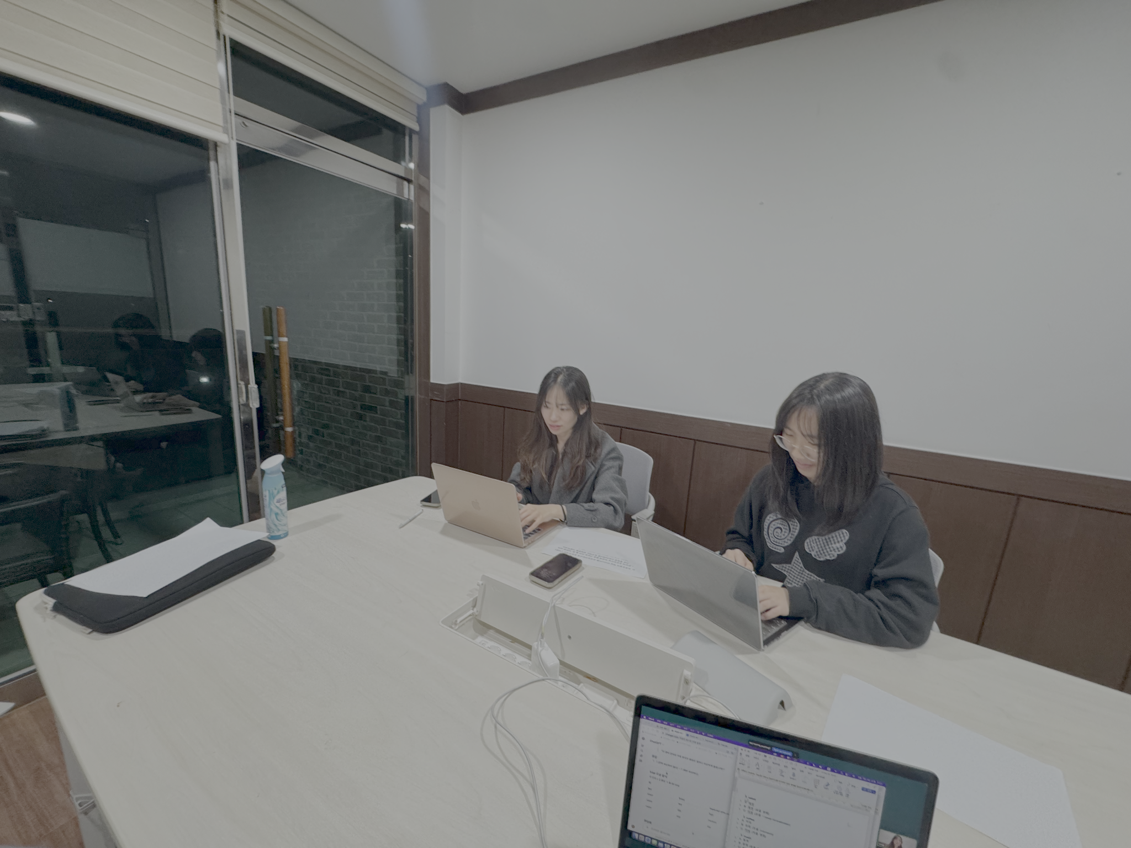
Figure C1. Representative photographs of the observation setting.

D. Detailed Observation Data

D.1. Observation Data
Table D1 presents a summary of behavioral observations recorded during the task sessions for each participant. Observations were organized according to six behavioral dimensions derived from the use cases identified in the analysis: long-term re-finding of old conversations (UC1), use of Cmd+F or keyword search (UC2), average response reading time (UC3), prompt revision count and method (UC4), attention shift threshold before switching to another behavior while waiting for a response (UC5), and number of scroll-back instances within a session (UC6).
Table D1. Participant-level behavioral observation summary
Participant | UC1: Long-term re-finding | UC2: Cmd+F use | UC3: Avg. response reading time | UC4: Prompt revision | UC5: Attention shift threshold | UC6: Scroll-back count
U1 | Not observed | Not observed | Task 1: ~42s / Task 2: ~10s | ~5 times | ~3s before next action | Task 1: 4 / Task 2: 5
U2 | Not observed | Not observed | Task 1: ~25s / Task 2: ~2–3s | ~3 times | Waited patiently throughout | Task 1: 2
U3 | Not observed | 1 time, Task 2 | Task 1: 60–90s / Task 2: ~11min (outlier) | ~1 time | Opened new session immediately without waiting | Task 1: 6 / Task 2: 3
U4 | Not observed | Not observed | Task 1: 20–45s / Task 2: ~10s | ~1 time per task | Waited; attempted new session after ~90s but did not switch | Task 1: 0 / Task 2: 0
U5 (excluded) | Not observed | Not observed | Early stage: 30–50s / Implementation: 1–2min | ~2 times | Shifted to other behavior after ~1min | ~4 times
U6 | Not observed | Not observed | Task 1: 1–2min / Task 2: ~2min 20s | Task 1: 1 / Task 2: 0 | ~40–45s; notably reopened Claude in a new tab due to slow response | Task 1: 2 / Task 2: 2
U7 | Not observed | Not observed | Early stage: ~1min / Implementation: 10–20s | ~2 times | Reviewed prior responses after 20s; stopped and re-asked after 55s; opened new chat after 80s | 1 time
U8 | Not observed | Not observed | Task 1: ~1min / Task 2: ~30s | Task 1: 0 / Task 2: 1 | ~15s before opening external document | Task 1: 6 / Task 2: 2
Note. UC1 was not directly observable due to the nature of the task design (see Section 3.1.2). U5 was excluded from the main analysis as described in Section 3.2. Task 2 reading time for U3 is treated as an outlier due to an unusually long initial response. Scroll-back count refers to the number of times a participant scrolled upward to revisit earlier responses within the same session.

D.2. Representative Screenshots
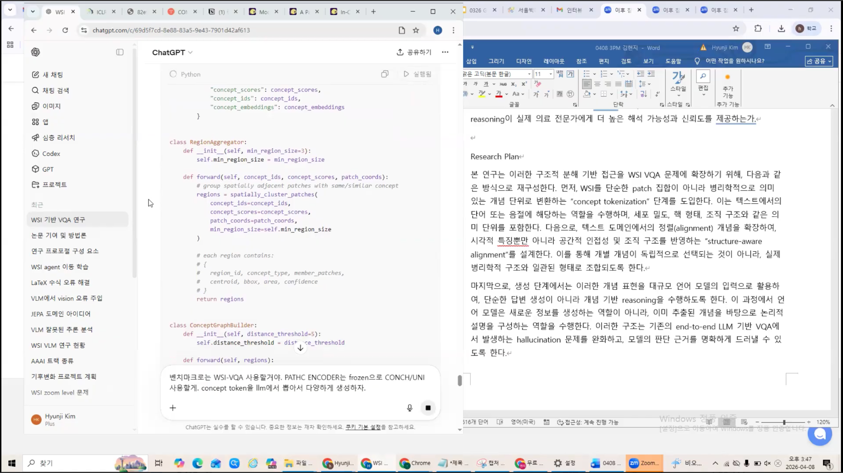
Figure D1. Representative screenshot of the observation task environment
This screenshot shows a participant using conversational AI and a document editor side by side while developing a research proposal during the observation task.

D.3. Full Recordings and Materials
The complete interview recordings, observation recordings, and supplementary materials used in this study are available in the shared Google Drive folder: https://drive.google.com/drive/folders/1Tdw7Y27QHmEhdA_t9s5U1WcVaT4w9JM3

E. Full Affinity Diagram

E.1. Initial Affinity Grouping
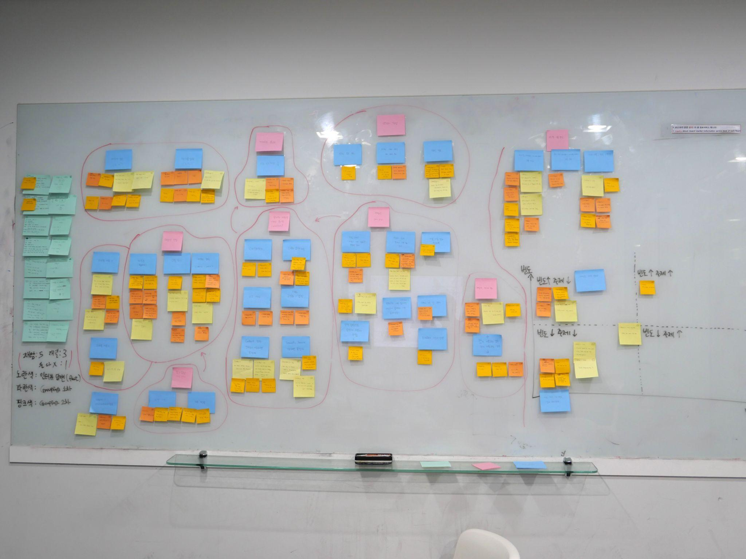
Figure E1. Initial affinity diagram on the whiteboard
The interview findings were first grouped on a physical whiteboard to identify recurring patterns, user behaviors, pain points, and needs related to re-finding and reusing past AI conversations.

E.2. Digitalized Version
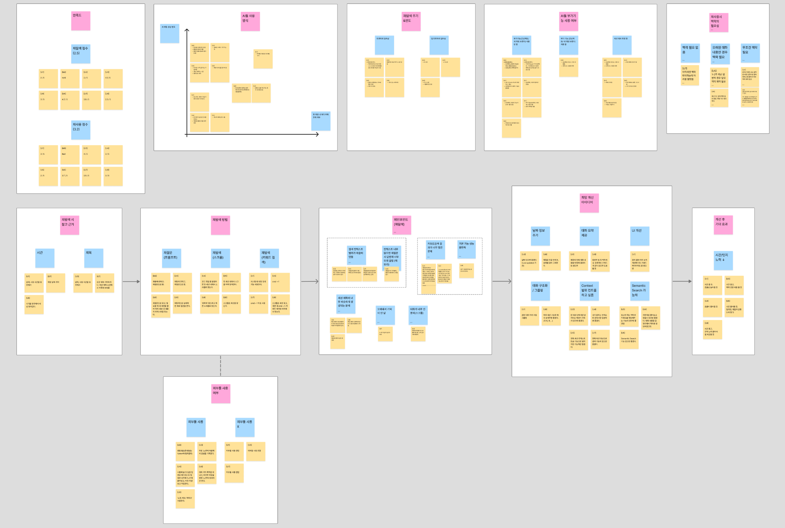
Figure E2. Digitalized version of initial affinity diagram
The initial whiteboard grouping was then converted into a digital affinity diagram. This version was used to refine the categories, compare user patterns, and derive higher-level insights.

E.3. Visualization of User Classification Results and Derived Insights
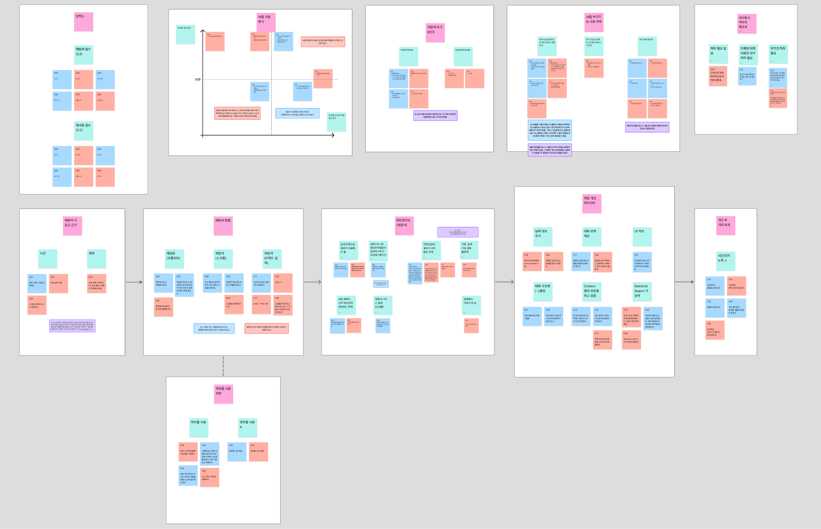
Figure E3. Visualization of user classification results
The user classification results were visualized using color-coded groups. Red and blue groups represent different user types identified through the analysis, and key insights were derived by comparing their behaviors, needs, and pain points.

E.4. Affinity Diagram Results
The full affinity diagram image is too large to be embedded directly in the report, so it is provided separately as a ZIP file. Please refer to the attached ZIP file submitted via KLMS for the full affinity diagram materials.

